GFA – Upgrade

March 2024

Contents

1. NAV 2009R2 to NAV 2015 4

I. Checks 4

II. Tasks 7

Task 1: Run Upgrade Step 1 in the Microsoft Dynamics NAV 2009 R2 or SP1 development environment (Classic client) 7

Task 2: Convert the Microsoft Dynamics NAV 2009 R2 or SP1 database to a Microsoft Dynamics NAV 2013 database 11

Task 3: Convert the Old Database to a Microsoft Dynamics NAV 2015 Format 15

Task 4: Connect a Microsoft Dynamics NAV 2015 Server Instance to the Converted Database 18

Task 5: Run Sch 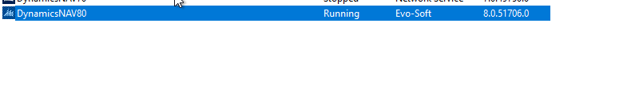ema Synchronization to initialize the database. 20

Task 6: Import the Application Objects to the Converted Database 24

Task 7: Run the Schema Synchronization 26

Task 8: Run the Data Upgrade to perform Upgrade Toolkit Step 2 27

Task 9: Delete the Upgrade Objects and Obsolete Tables 31

k 10: Import upgraded permission sets and permissions by using the Roles and Permissions XMLports 32

Task 11: Set the Language of the Customer Database 32

Task 12: Add New Control Add-ins 32

3. NAV 2015 to BC14 33

Document 33

Task 1: Create full SQL backup of old database 34

Task 2 Uninstall all extensions in old database 34

Task 3: Upload Business Central partner license to old database 35

Task 4: Delete all objects except tables in old database 35

Task 5: Clear server instance and debugger breakpoint records in old database 36

Clear all records from the dbo.Server Instance and dbo.Debugger Breakpoint tables in the database in SQL Server. 36

1. Make sure that you stop the old server instance, and close any tools that connect to the database, such as the Dynamics NAV Administration Tool and development environment. 36

2. Using SQL Server Management Studio, open and clear the dbo.Server Instance and dbo.Debugger Breakpoint tables of the old database. For example, you can run the following SQL query: 36

DELETE FROM [<My NAV Database Name>].[dbo].[Server Instance] 36

DELETE FROM [<My NAV Database Name>].[dbo].[Debugger Breakpoint] 36

Task 6: Convert old database to Business Central (Run as administrator) 37

Task 7: Import upgraded application objects to converted database 38

Task 8: Connect a Business Central Server instance to converted database 38

Task 9: Compile all objects in converted database 40

Task 10: (Upgrade from Dynamics NAV 2018 or Business Central Fall 2018 only ) Increase the application version of converted database 42

3. BC14.51 to BC23.0 46

Script 1 46

Script 2 47

4. BC23.0 to BC24.1 63

In the GO Live we choose to upgrade BC23.0 directly to BC24.1 final version 63

Script 1 63

Script 2 63

# NAV 2009R2 to NAV 2015

## Checks

Connections

VPN: GFA

Server : 192.168.13.14

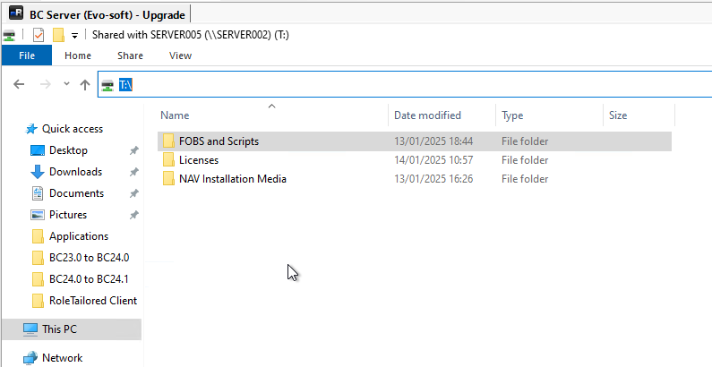

Before running the upgrade, ask the consultant to review the data the following issues that could halt the NAV 2015 Data Upgrade:

* + There must be no Item Journal Lines.
  + There must be nothing in the Standard Cost Worksheet.
  + You must remove Windows Logins that are showing GUIDS rather than resolving to names (i.e. these Windows Users no longer exist).
  + There are missing bins in GFA RE Ltd: AGINCOURT: PROD IN, PROD OUT, SPARES: PROD IN, PROD OUT. A zone may need to be created and the bins need to have the correct Bin Type to avoid a further error. Ask Manuel for more information.
  + There are dimension combinations that have been deleted. These have been manually rectified by Manuel for the trial run but will need doing again for go-live. Check with Manuel that this has been done.

You will need a license that is suitable for running the upgrade. Because NAV 2018 and earlier dev licenses are no longer available, an alternative must be used.

* Back up the database.

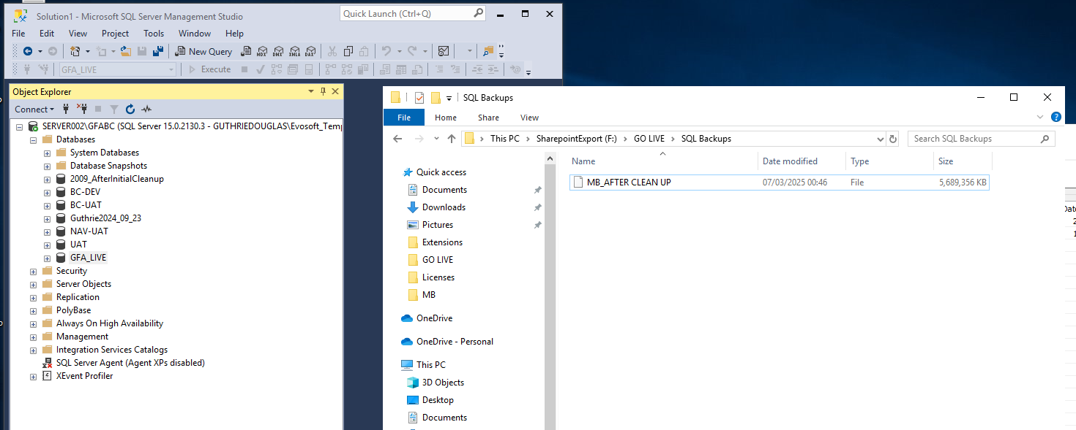

* Remove custom data and restore database to standard 2009R2 objects.

**This tool is destructive and will clear custom fields and tables in the customer’s database.**

Import and execute codeunit 50098 in the “ClearCustomFields.fob” file in the Upgrade Resources.

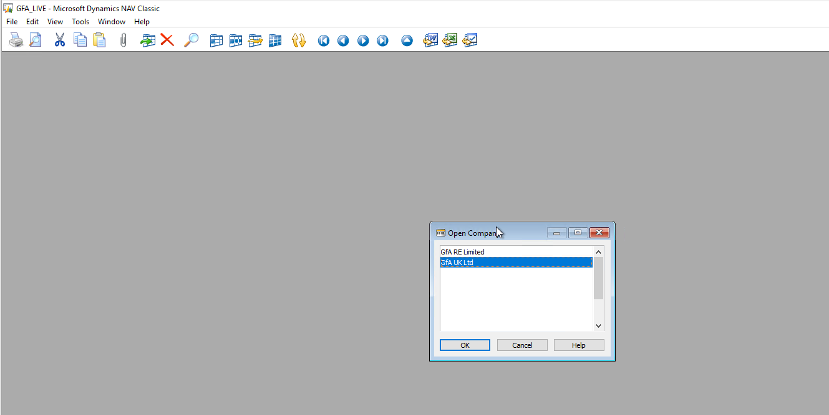



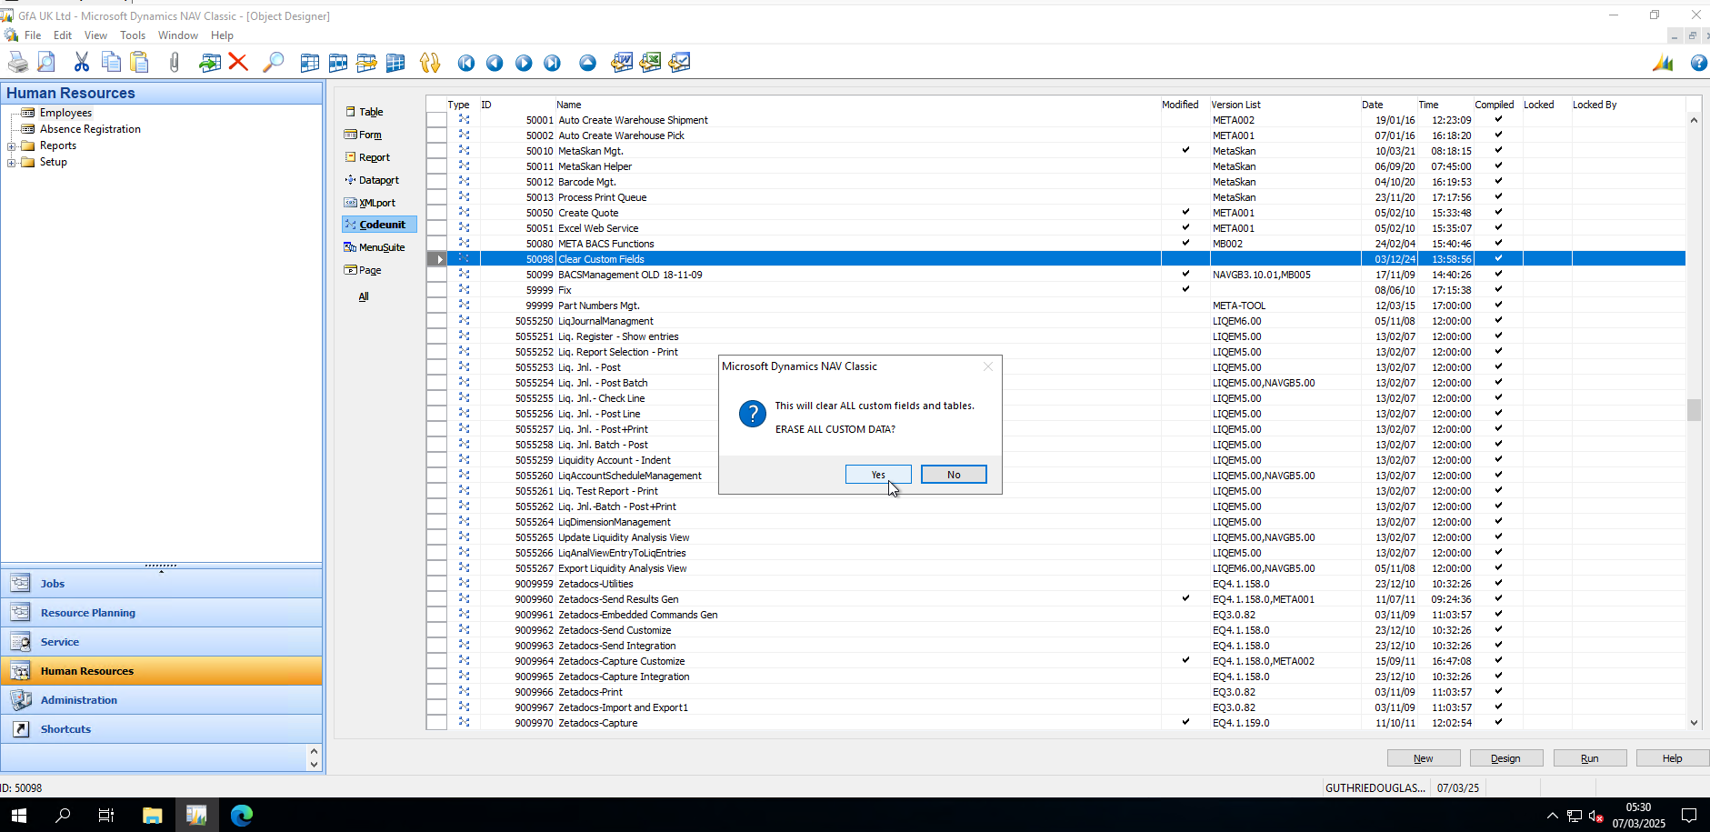

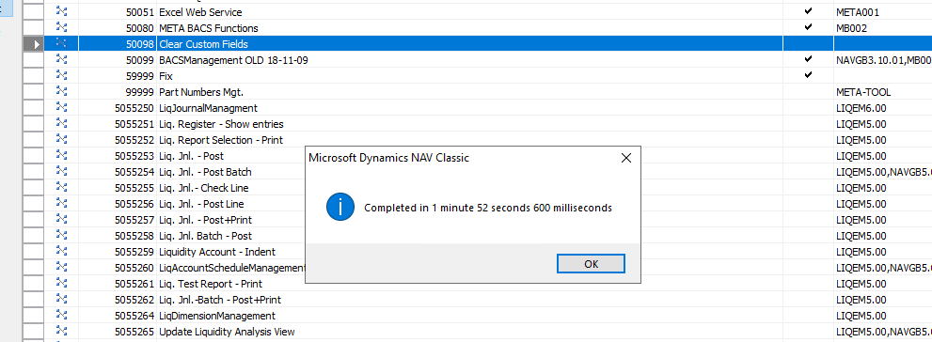

* Import and replace the clean 2009R2 object set in the Upgrade Resources. This will replace all objects with standard objects



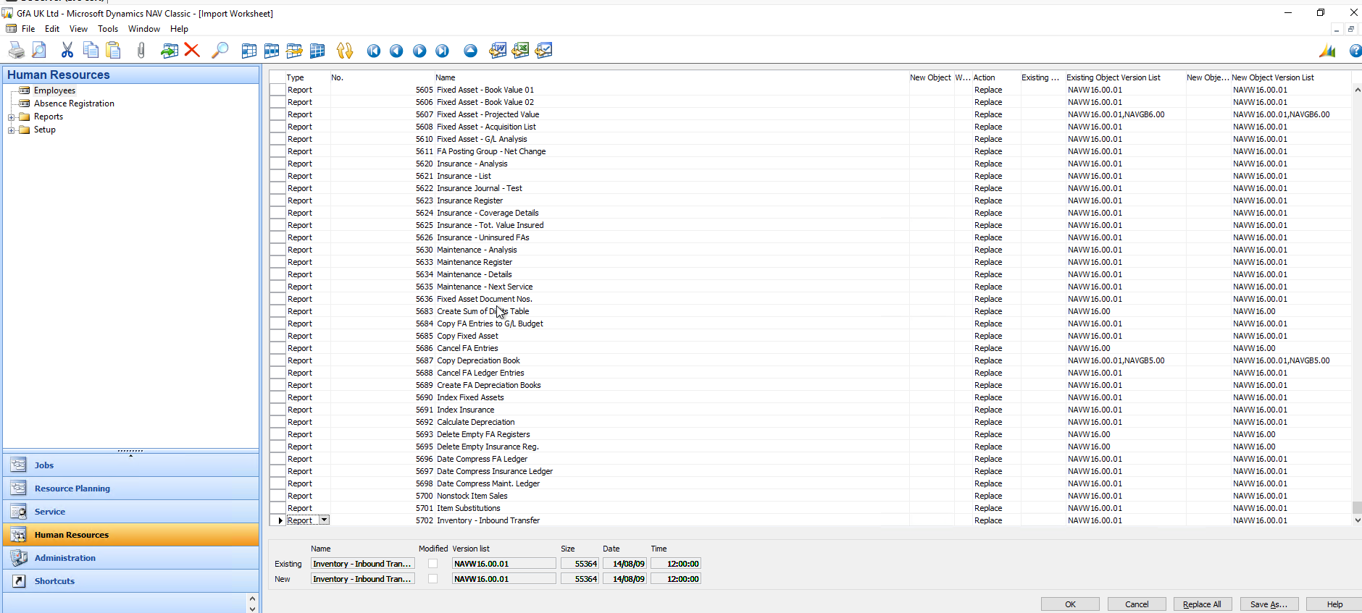

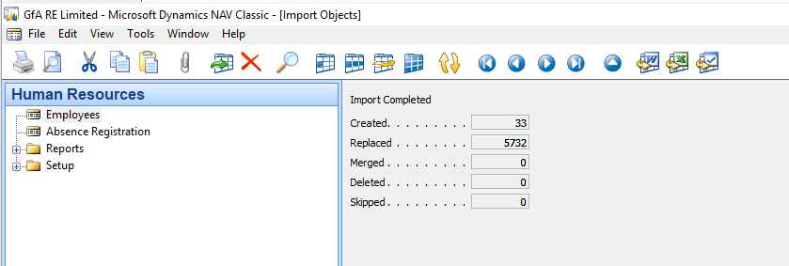

* Delete all objects in the 50000..99999 range and other custom objects such as Zetadocs. Objects related to the Liquidity granule can be left alone.
* 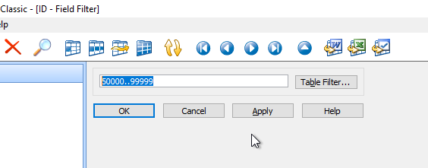

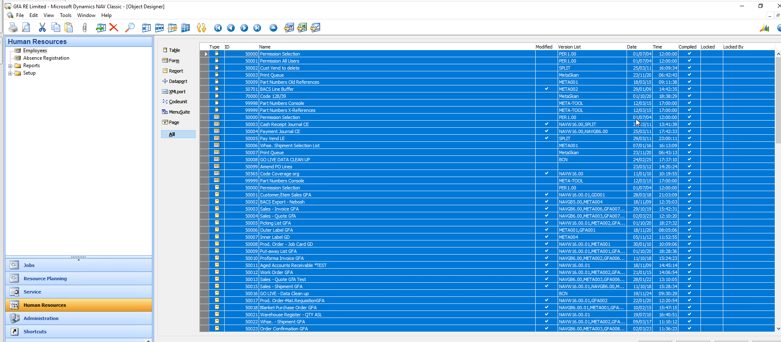

## Tasks

## Task 1: Run Upgrade Step 1 in the Microsoft Dynamics NAV 2009 R2 or SP1 development environment (Classic client)

[Document](https://www.microsoft.com/en-us/dynamics-365/blog/no-audience/2015/02/23/upgrading-from-microsoft-dynamics-nav-2009-r2-or-microsoft-dynamics-nav-2009-sp1-to-microsoft-dynamics-nav-2015/)

1. Make sure that all table objects have compiled successfully.

To compile all table objects, in Object Designer, select all objects of type Table, and then on the Tools menu, choose Compile. During compilation, Microsoft Dynamics NAV generates or regenerates the BLOB content in the Object Metadata table that is used in the later steps.

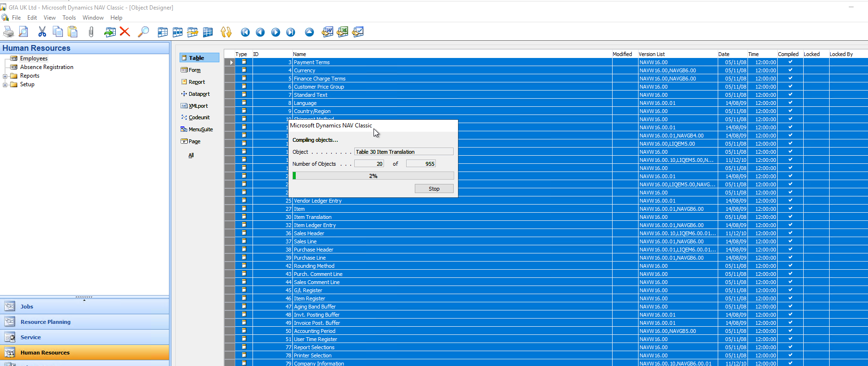

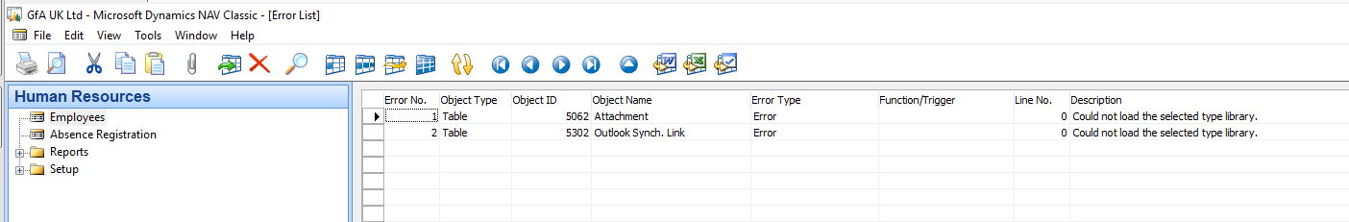

1. Create a copy or a backup of the Microsoft Dynamics NAV 2009 R2 or Microsoft Dynamics NAV 2009 SP1 database and open it in the Microsoft Dynamics NAV 2009 R2 or Microsoft Dynamics NAV 2009 SP1 development environment.

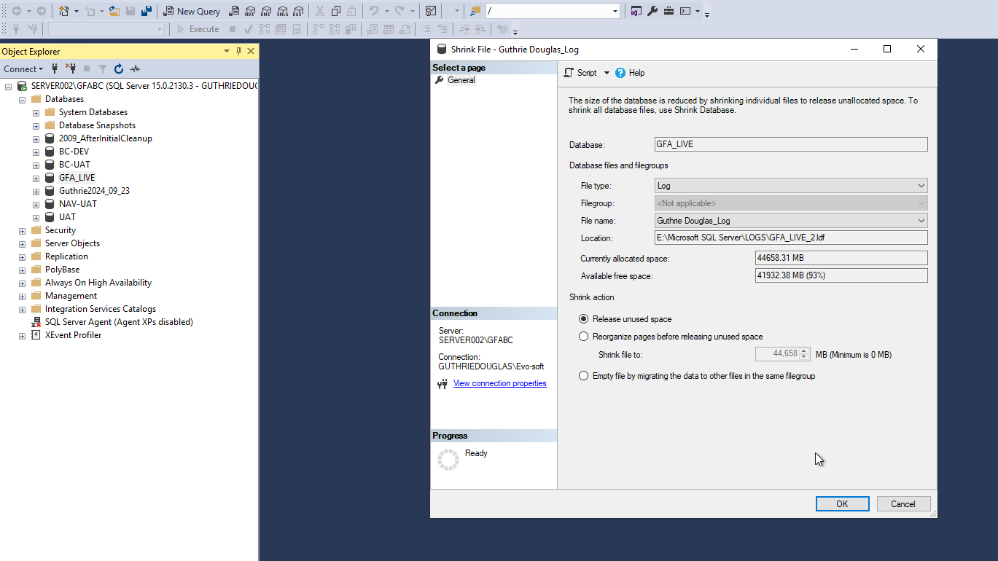

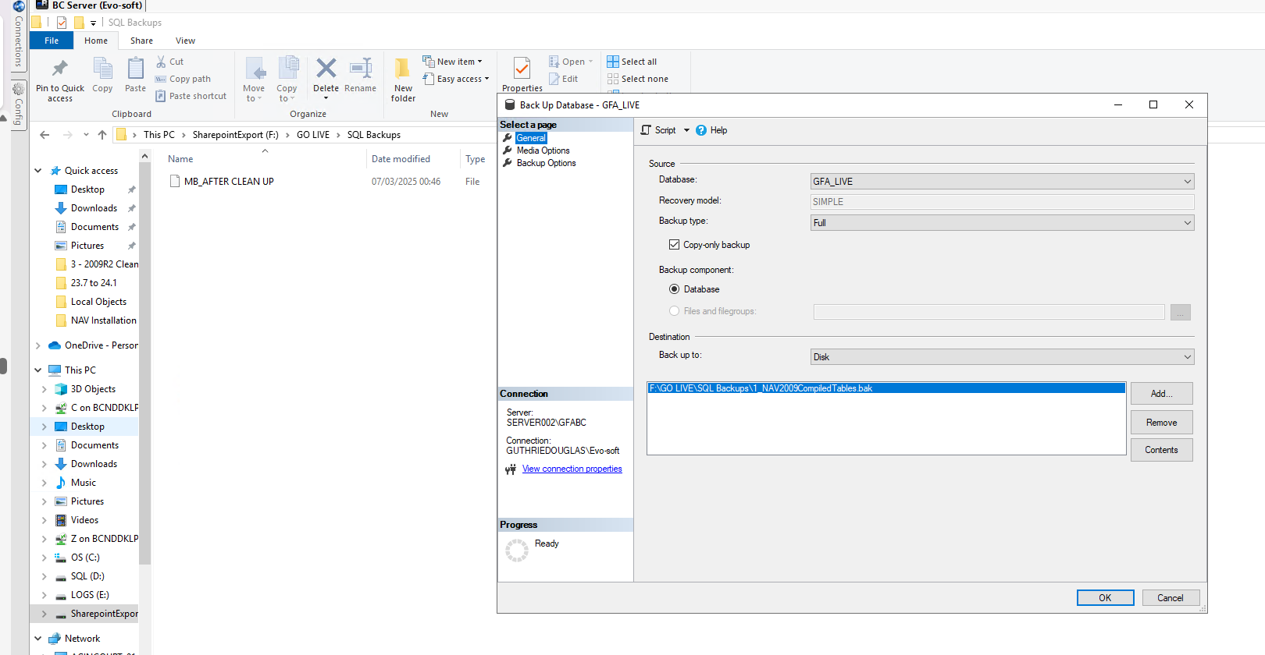

3. Add your Microsoft Dynamics NAV 2015 partner license to the database.

You can do this by selecting the Save License in Database field in the Alter Database window. If the field was not already selected, a dialog box opens so you can specify the location of your partner license. If the field was already selected, upload the partner license in the License Information window."

Open Object Designer, and then import Upgrade601800.[Country].1.fob from the \UpgradeToolKit\Local Objects folder. In the Import Worksheet window, choose Replace All, and then choose the OK button to import the objects.

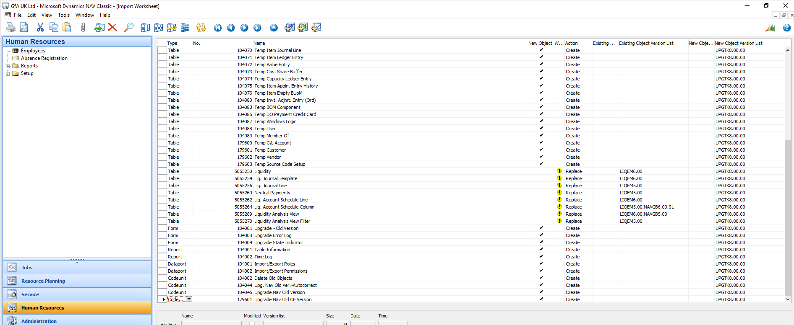

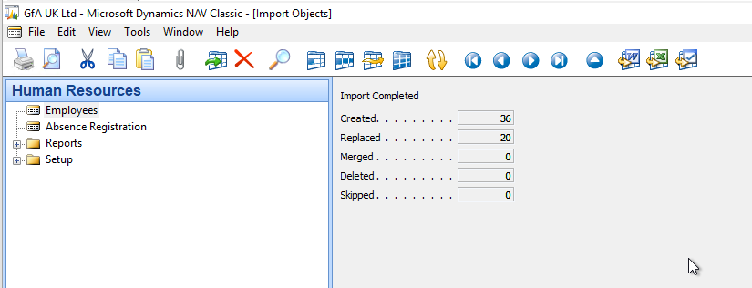

5. For each company in the database, do the following:

Open the company and make the relevant changes to data.

In Object Designer, run form 104001, Upgrade – Old Version. Choose the Transfer Data button. Important: After you have completed this step for all companies, we strongly recommend that you create a full SQL backup the database by using SQL Server management tools.

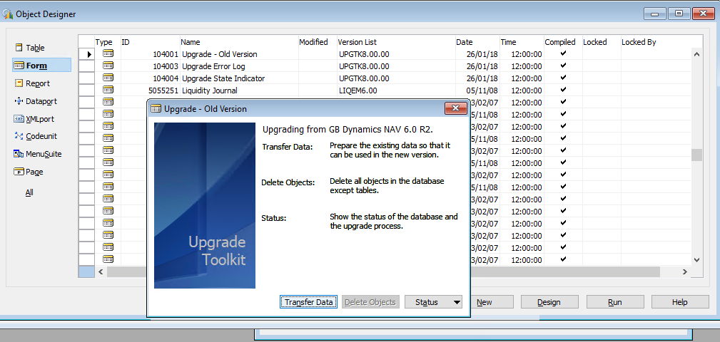

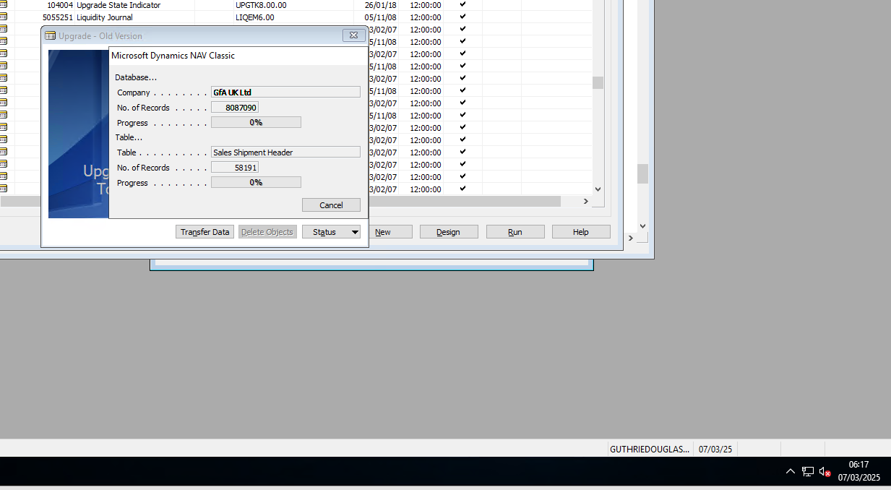

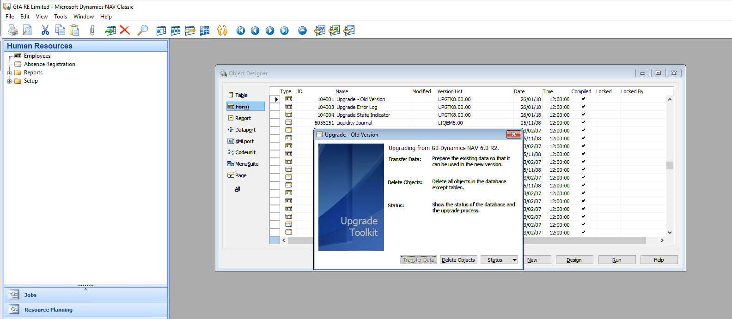

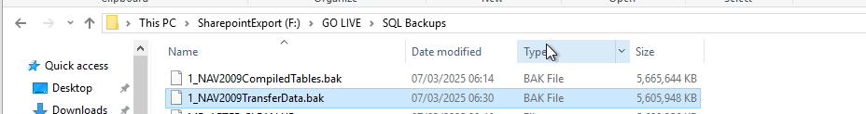

When you have transferred all data for all companies, in the Upgrade – Old Version window, choose the Delete Objects button.

This action deletes all objects in the database that are not tables, but also obsolete tables that belong to functionality that is not available in Microsoft Dynamics NAV 2015.

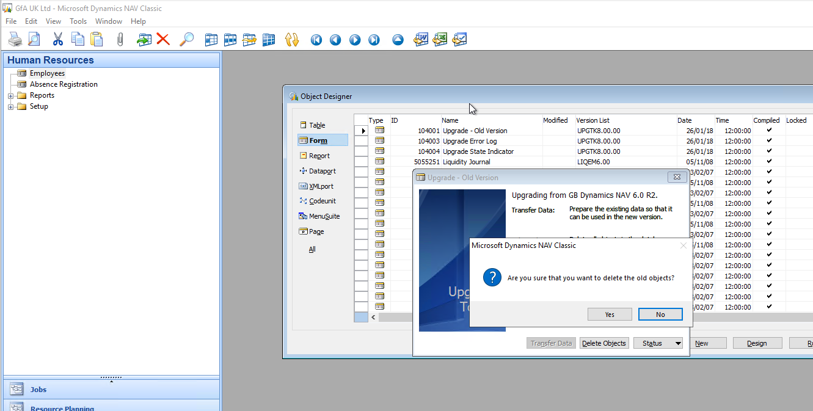

## Task 2: Convert the Microsoft Dynamics NAV 2009 R2 or SP1 database to a Microsoft Dynamics NAV 2013 database

1. Uninstall Microsoft Dynamics NAV 2009 R2.

2. Download the latest available Cumulative Update for Microsoft Dynamics NAV 2013.

3. Run the installation program (setup.exe) for Microsoft Dynamics NAV 2013, choose an installation option, choose Custom, and then choose the Client option (with the Development Environment).

Change the compatibility level of the database according to the following:

For SQL Server 2008 R2 the compatibility level of the database to 100.

For SQL Server 2012, set the compatibility level of the database to 110.

To do this, you use Microsoft SQL Server Management Studio as follows:

Start Microsoft SQL Server Management Studio and connect to the SQL Server instance that includes the Microsoft Dynamics NAV database.

Right-click the Microsoft Dynamics NAV database, and then select Properties.

In the Database Properties window, choose the Options page, and then set the Compatibility Level to the correct value.

Before

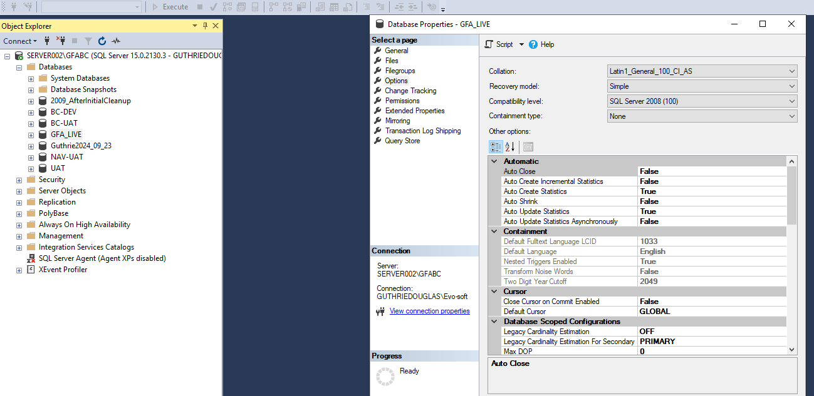

After

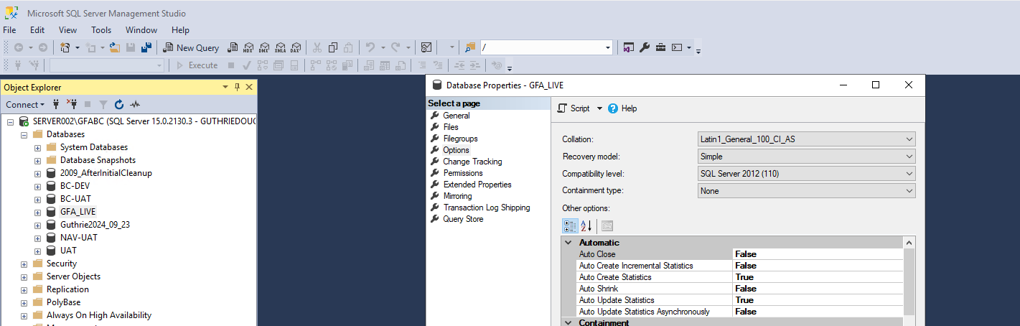

In the Microsoft Dynamics NAV 2013 development environment, open the Microsoft Dynamics NAV 2009 R2 or Microsoft Dynamics NAV 2009 SP1 database and agree to convert the database.

During this step, Microsoft Dynamics NAV converts all text and code fields to Unicode format by changing their SQL Server data type. This conversion requires more disk space than usual, since both the database and the log file will grow in size considerably. It can also be a lengthy process.

If your Microsoft Dynamics NAV 2009 R2 database is using SQL Server Collation, within the same step the collation will be changed to a suitable Windows collation. This is because Microsoft Dynamics NAV 2013 and higher versions only support Windows Collation. Important: After the database conversion has been completed, we strongly recommend that you create a full SQL backup of the database.

The technical upgrade of the database to Microsoft Dynamics NAV 2013 is complete. You can now uninstall Microsoft Dynamics NAV 2013

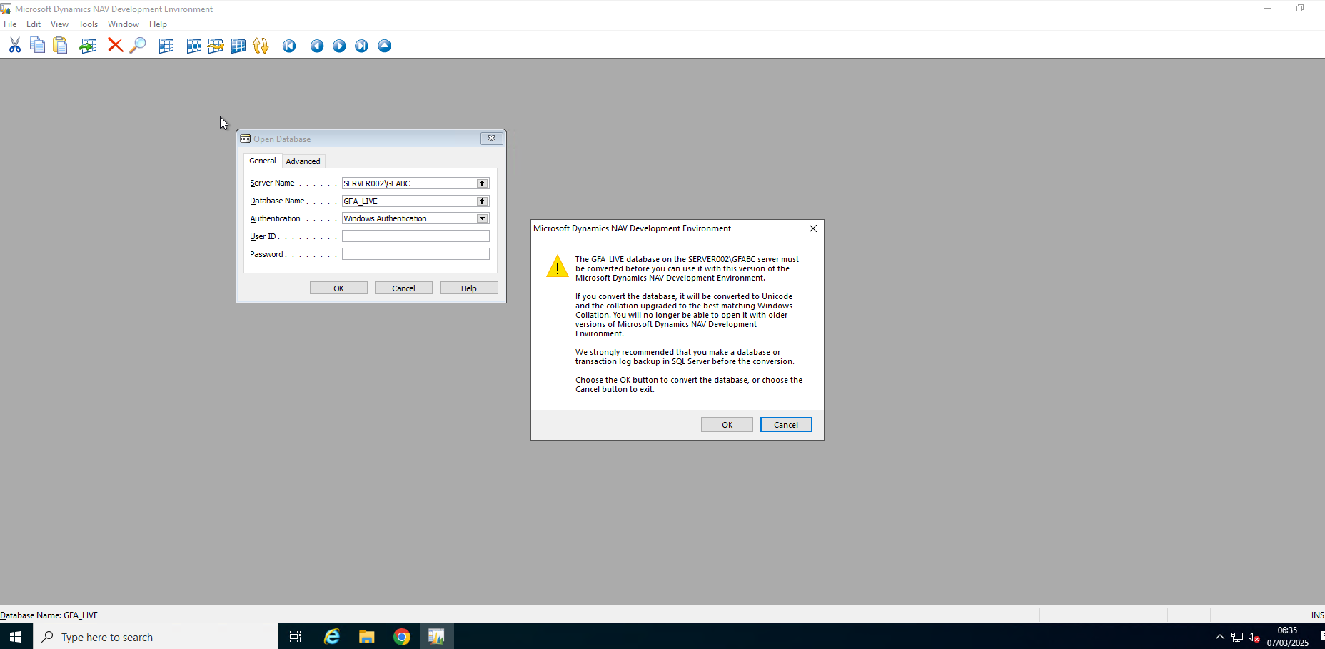

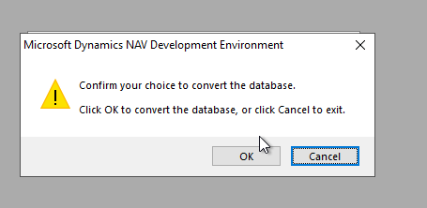

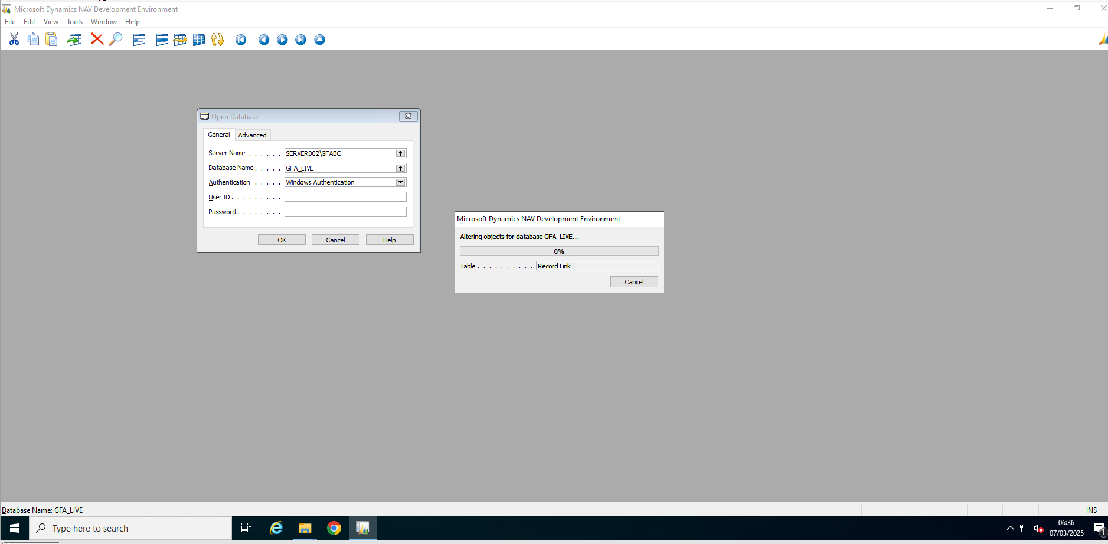

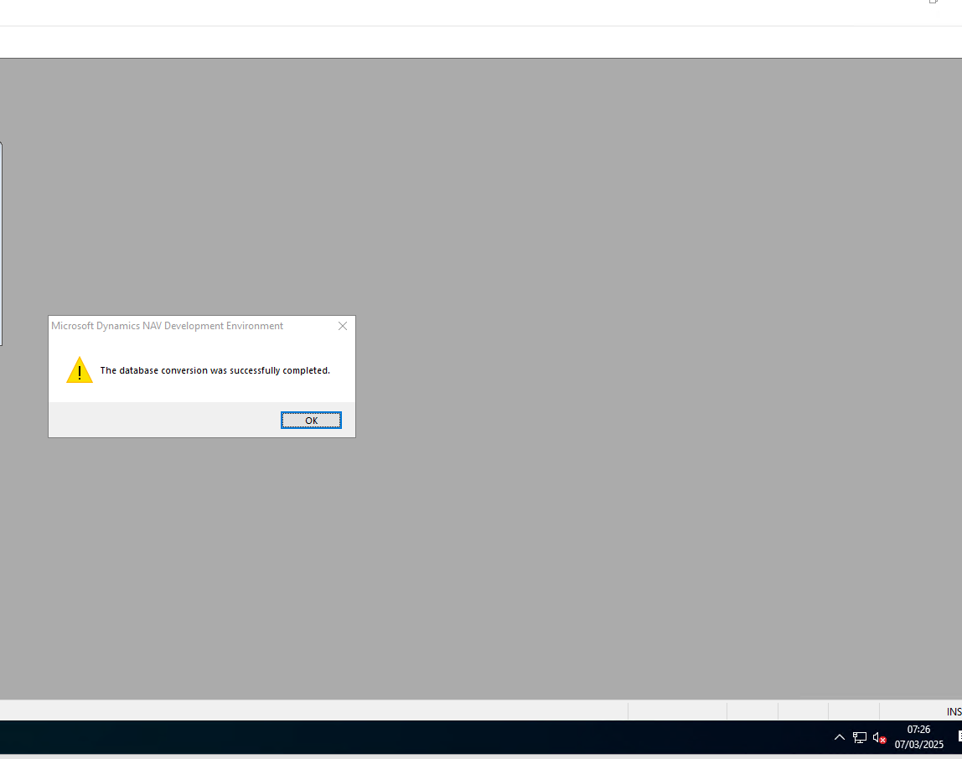

Backup Database

Shrink Log

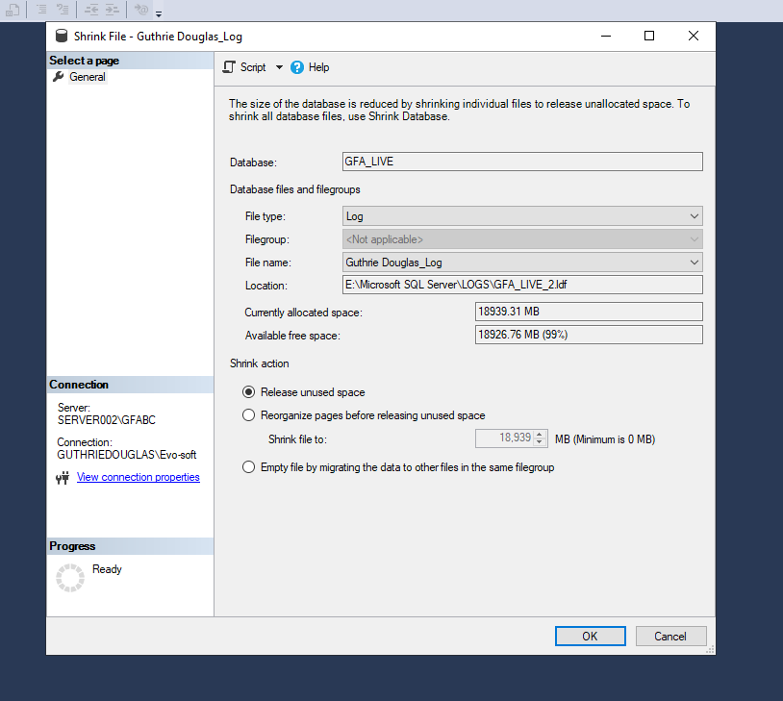

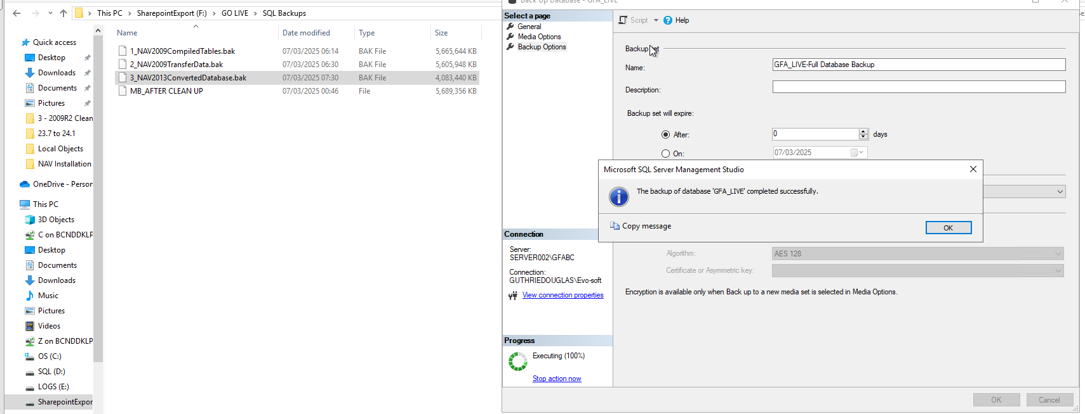

## Task 3: Convert the Old Database to a Microsoft Dynamics NAV 2015 Format

1. Install Microsoft Dynamics NAV 2015.

During the installation of Microsoft Dynamics NAV 2015, select the Choose an installation option, then select the Custom option, where you choose to install the Client (with the Development Environment), Server, and Administration Tool components."

1. To convert the old database to a Microsoft Dynamics NAV 2015 format, open the old database in the Microsoft Dynamics NAV 2015 development environment, and then follow the instructions.

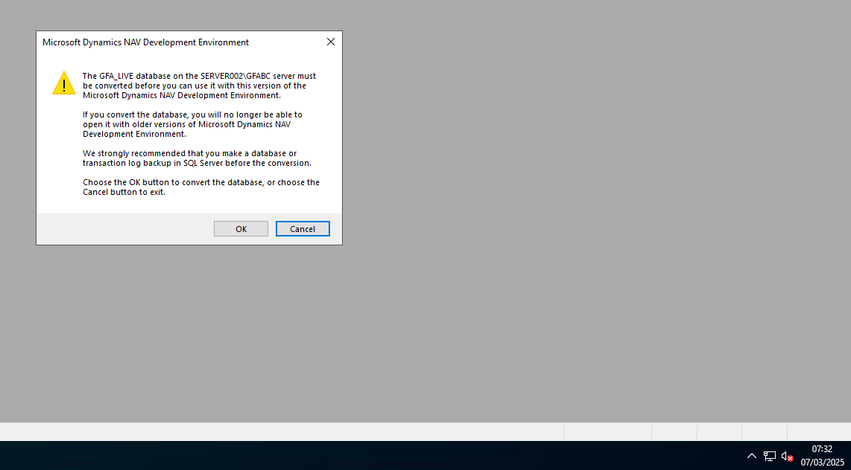

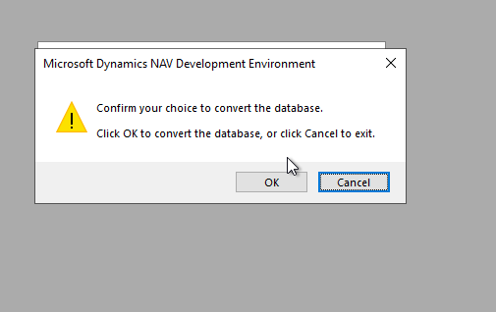

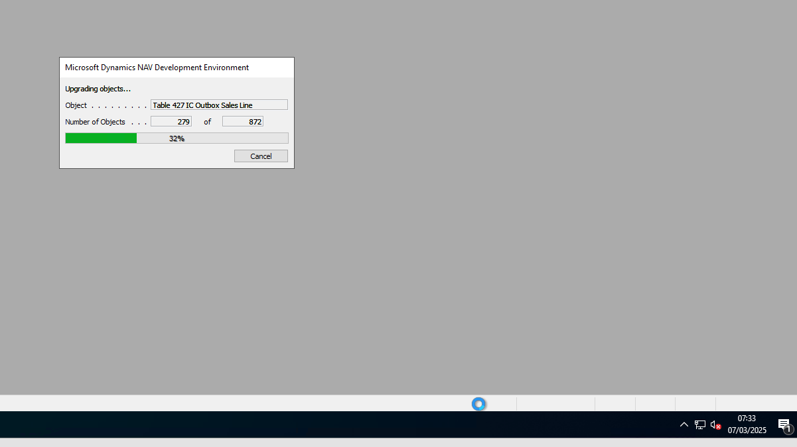

1. After the database conversion is completed, verify that all system tables are compiled.

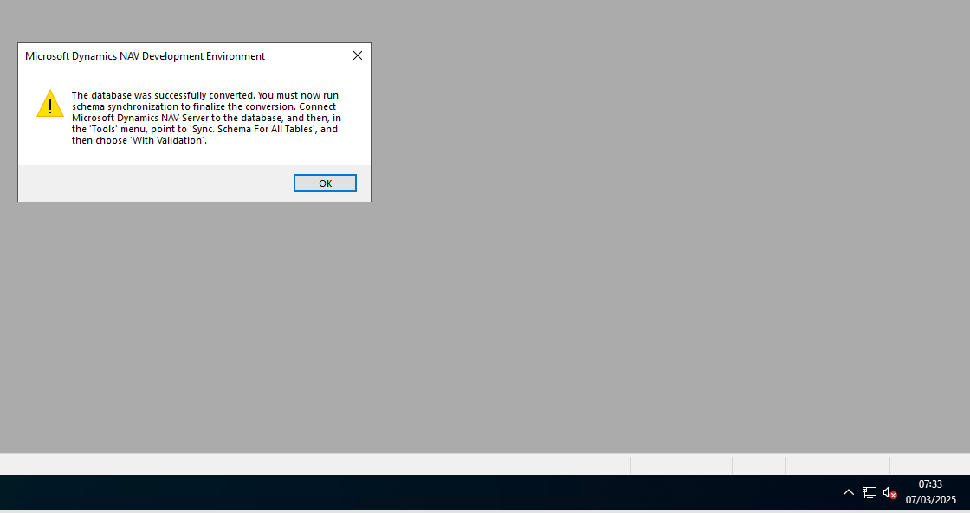

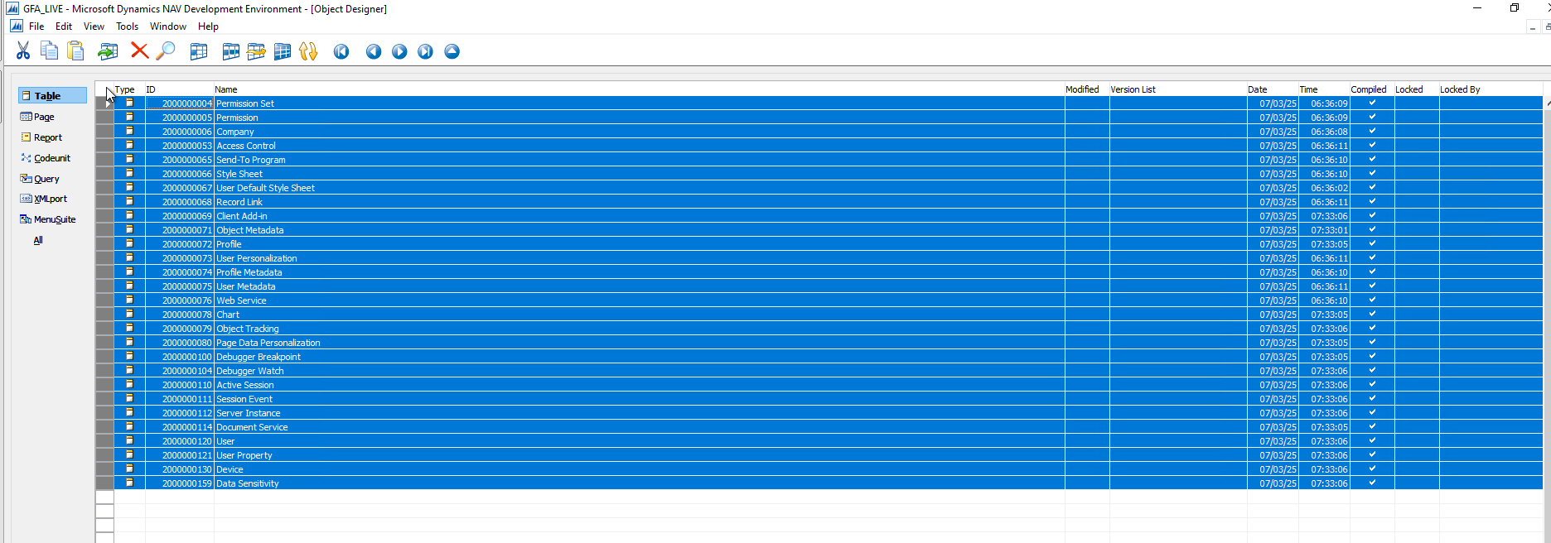

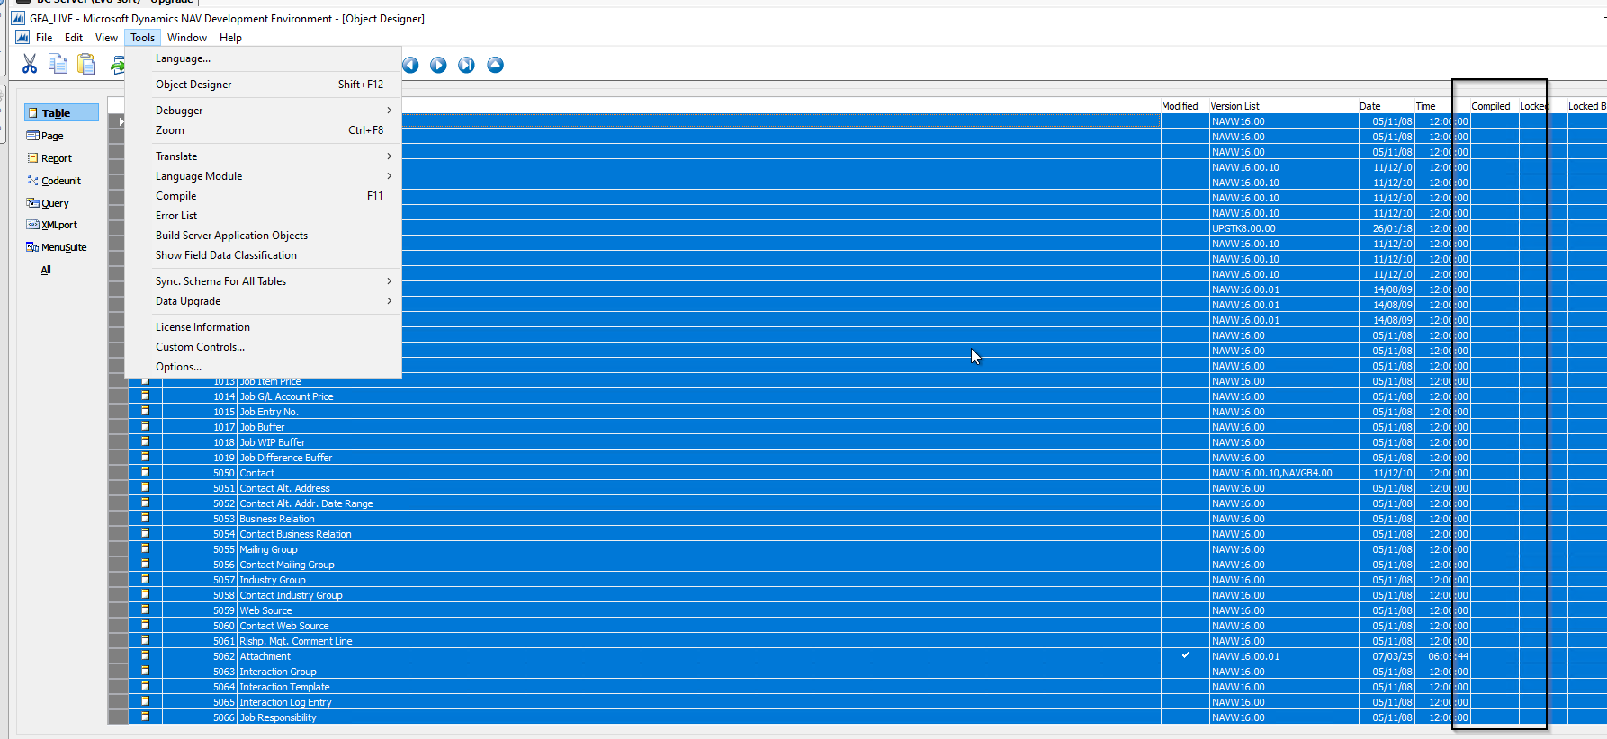

System tables have IDs in the range 2000000004 to 2000000130. If any tables are not compiled, then you must compile them. When you compile tables, on the Compile dialog box, set the Synchronize Schema option to Later.

## Task 4: Connect a Microsoft Dynamics NAV 2015 Server Instance to the Converted Database

1. Using Microsoft SQL Server Management studio, add the service account that is used by the Microsoft Dynamics NAV Server instance (for example, NT AUTHORITY\NETWORK SERVICE) as a member of the db_owner role in the Microsoft Dynamics NAV database on SQL Server.

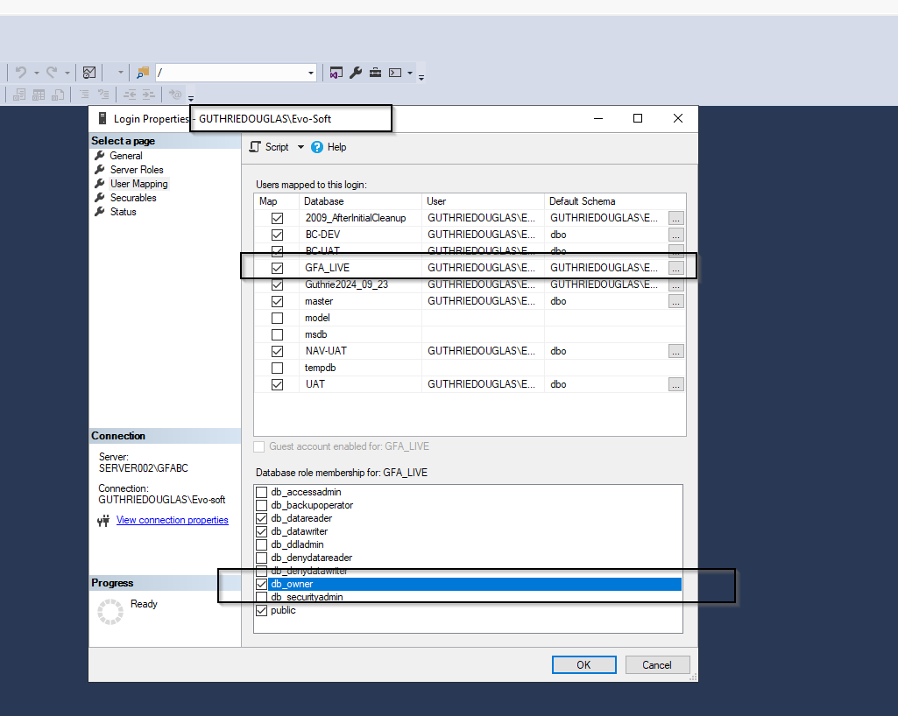

1. Using the Microsoft Dynamics NAV Server Administration tool, connect a Microsoft Dynamics NAV Server instance to the converted database.

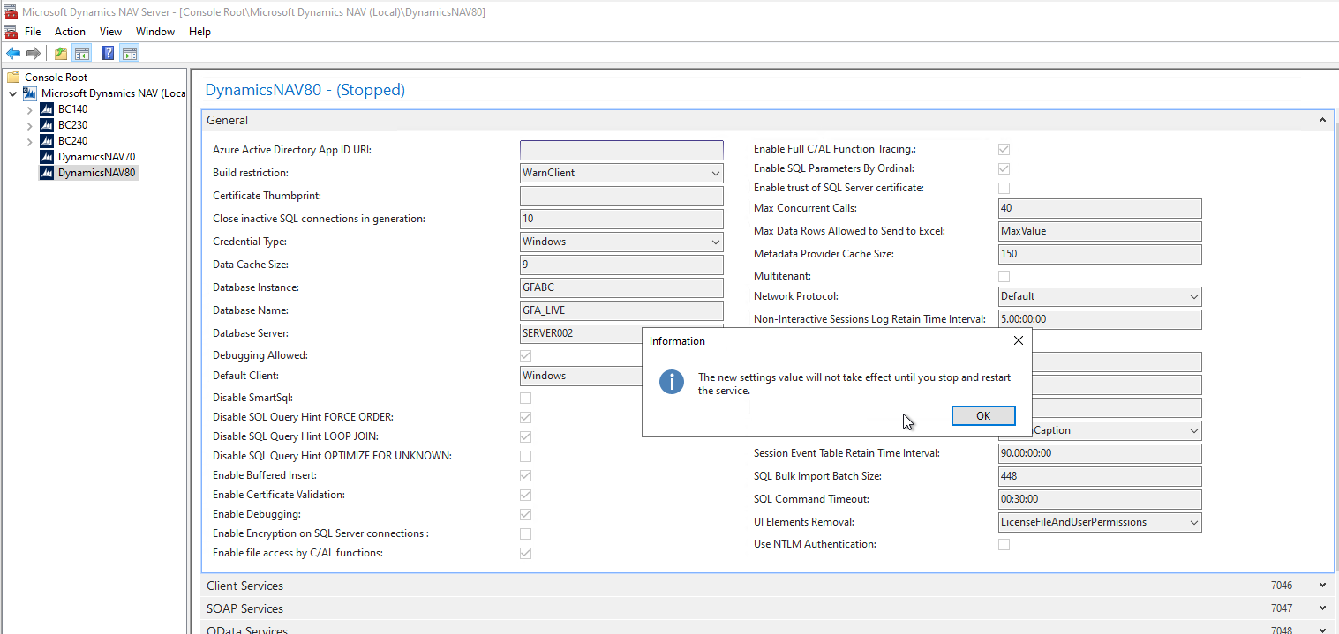

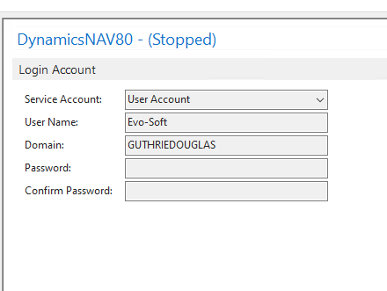

## Task 5: Run Schema Synchronization to initialize the database.

You can run the schema synchronization from the Microsoft Dynamics NAV Development Environment or Microsoft Dynamics NAV 2015 Administration Shell.

From the development environment:

1.Open development environment as an administrator.

2.On the Tools menu, choose Sync. Schema For All Tables, and choose With Validation, and then follow the schema synchronization instructions.

Upload internal license

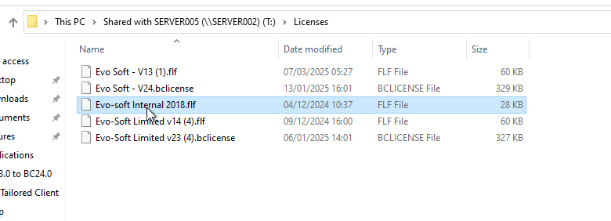

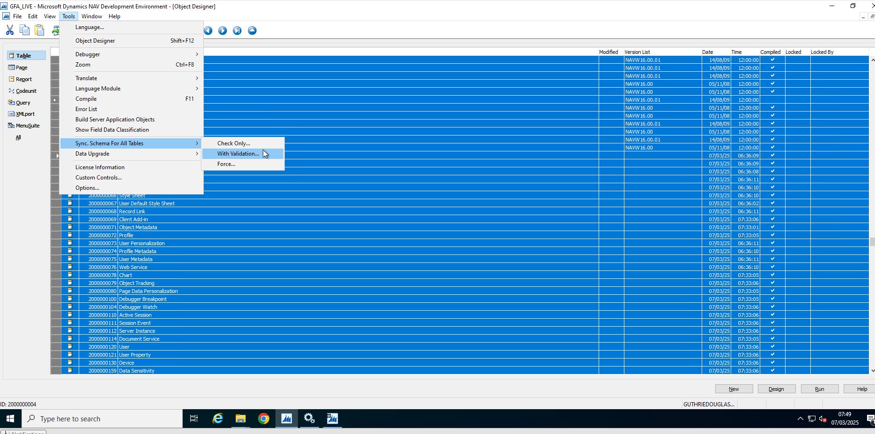

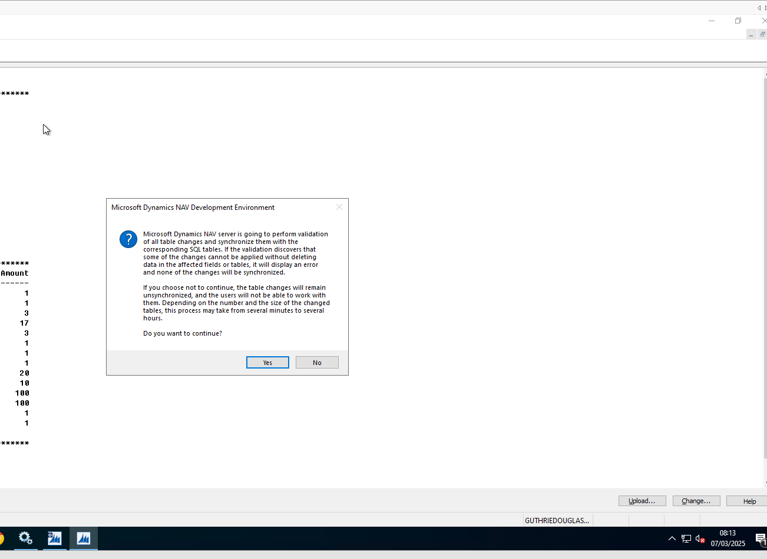

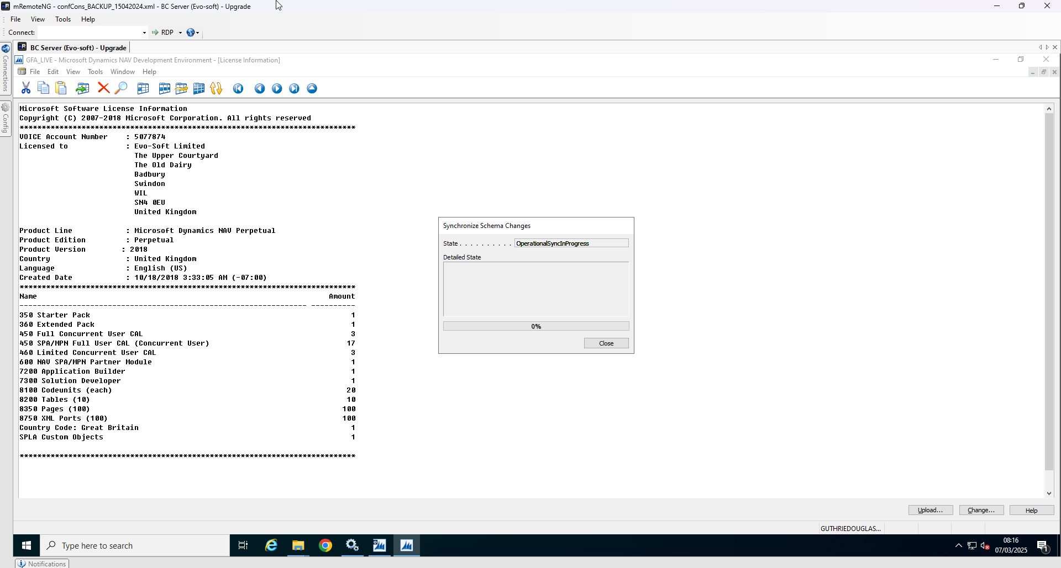

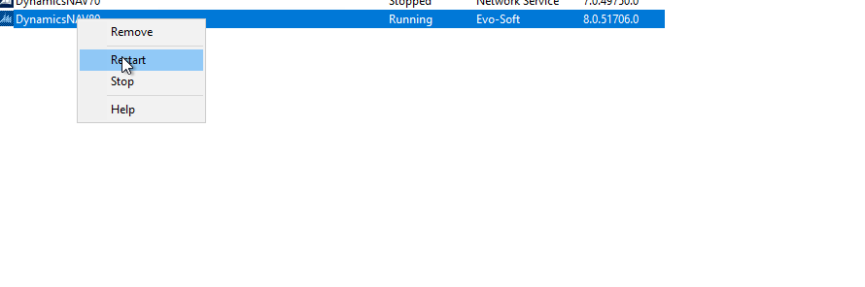

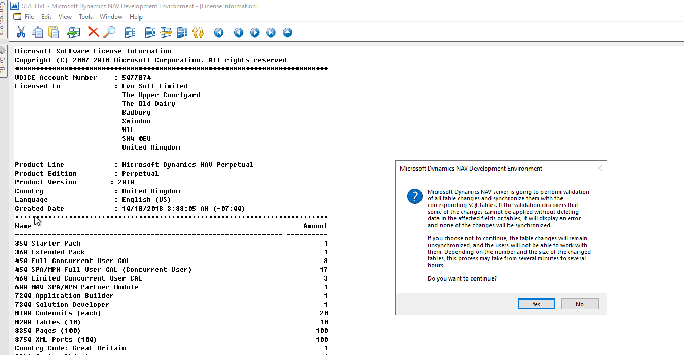

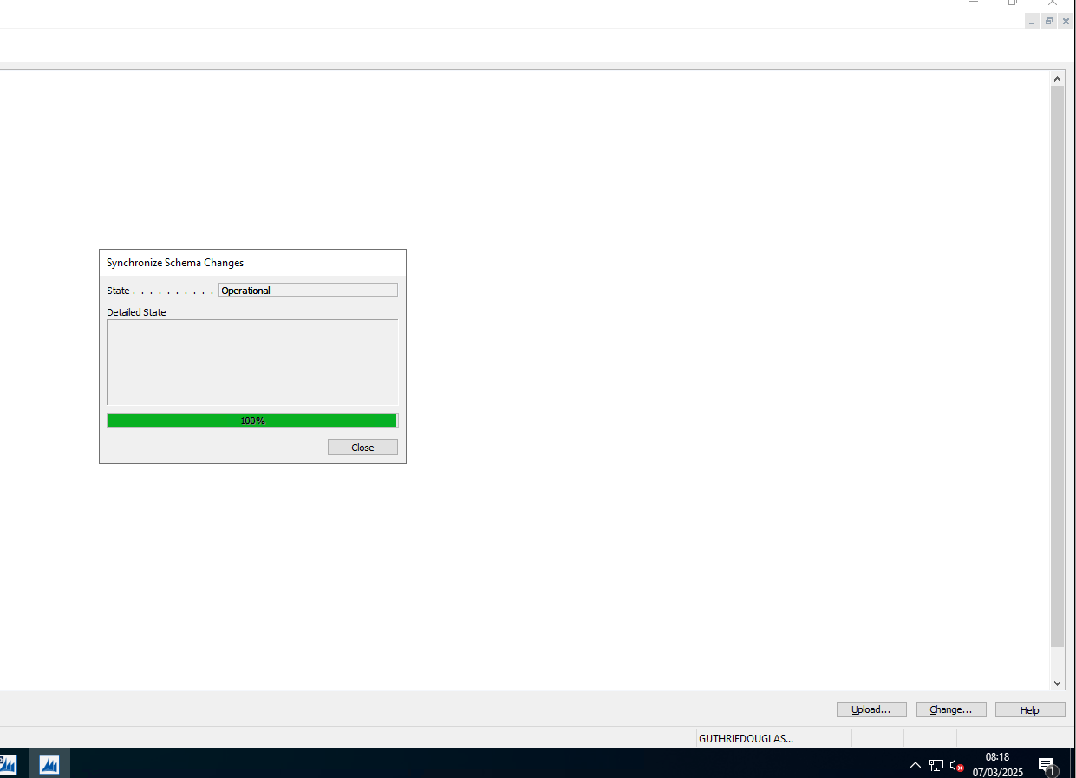

If synchronization errors occur, run the schema synchronization from Microsoft Dynamics NAV 2015 Administration Shell as described in the following procedure. This enables you to get the complete list of tables that could not be synchronized.

From the Microsoft Dynamics NAV 2015 Administration Shell:

Open the Microsoft Dynamics NAV 2015 Administration Shell as an administrator.

Run Sync-NavTenant cmdlet as follows:

Sync-NavTenant –ServerInstance <ServerInstanceName> -Mode Sync

Replace <ServerInstanceName> with the name of the Microsoft Dynamics NAV Server instance that is connected to the database.



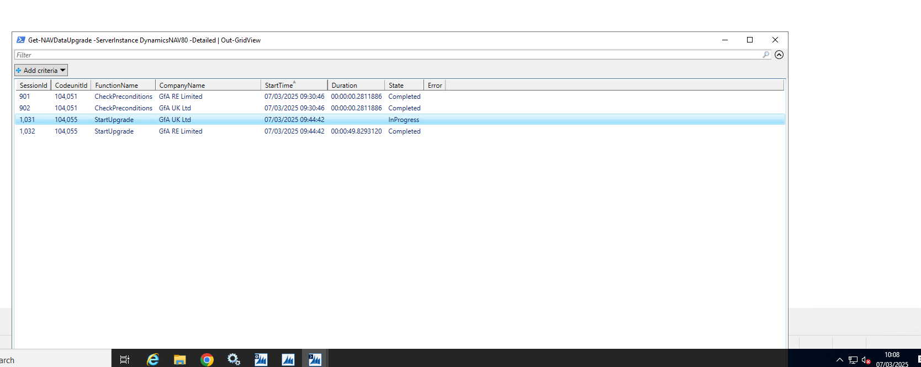

## Task 6: Import the Application Objects to the Converted Database

1. In the development environment, import all the application objects that you want in the Microsoft Dynamics NAV 2015 database.

When you import the FOB file that contains the Microsoft Dynamics NAV 2015 objects, on the Import Worksheet, choose Replace All, and then choose the OK button to import the objects.

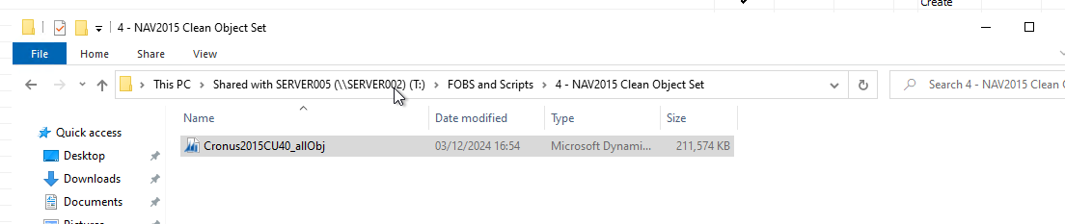

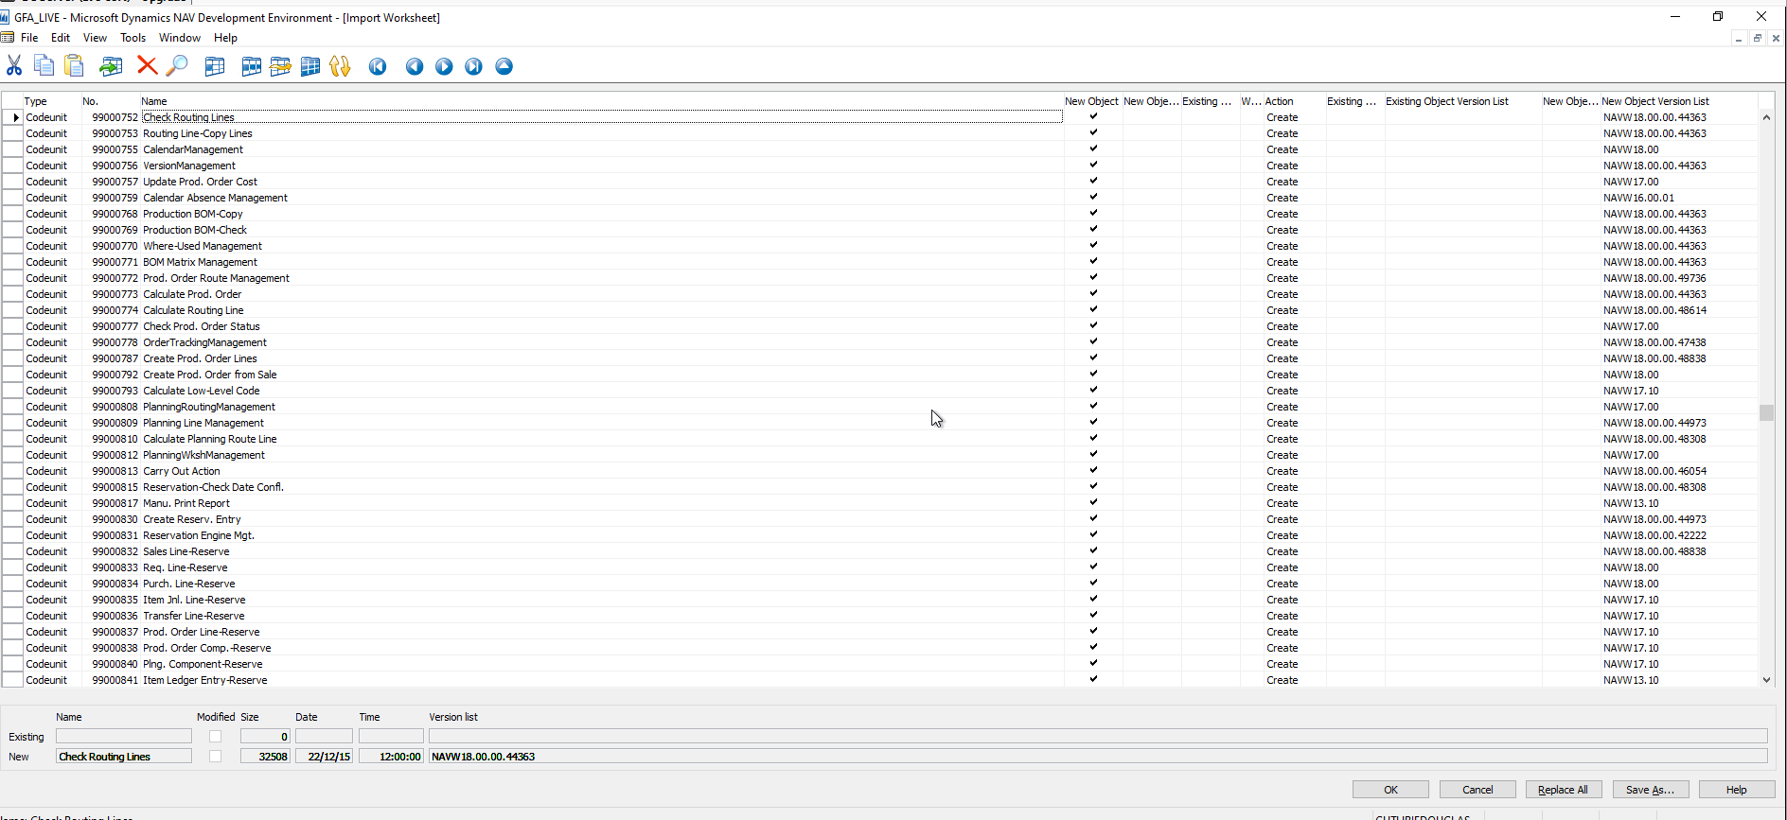

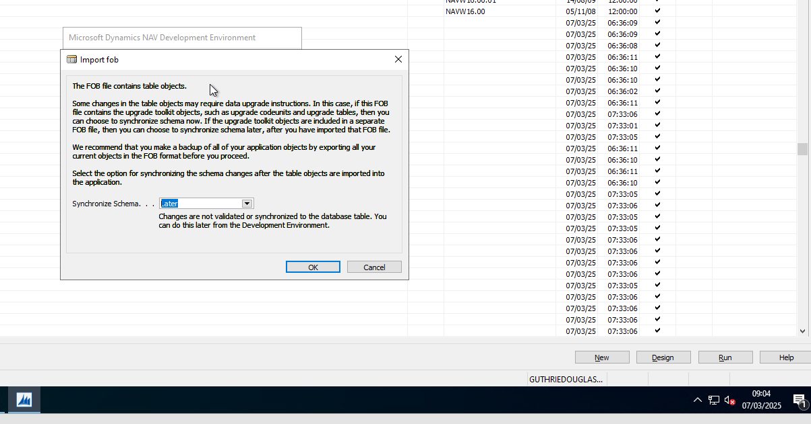

On the dialog box for selecting the schema synchronization, set the Synchronize Schema option to Later."

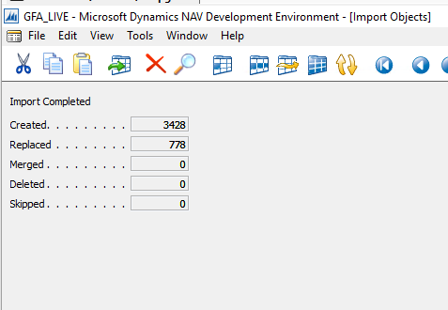

1. After you have imported Microsoft Dynamics NAV 2015 objects, import the upgrade toolkit FOB file Upgrade601800.[Country].fob from \UpgradeToolKit\Local Objects folder.

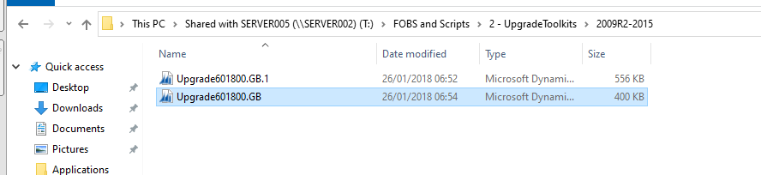

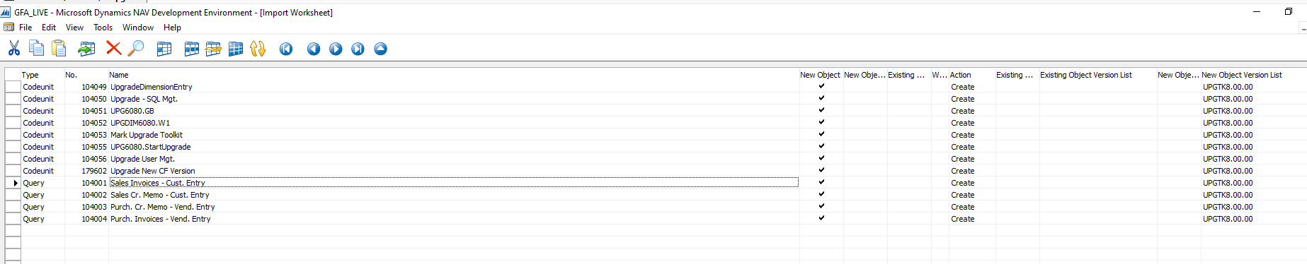

1. Compile all objects that have not been compiled yet.

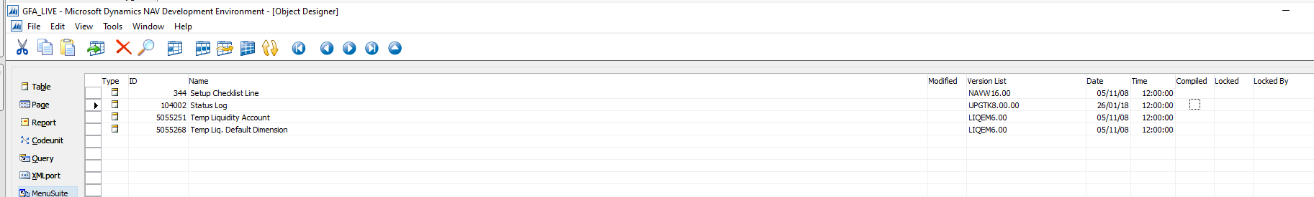

On the Compile dialog box, set the Synchronize Schema option to Later.

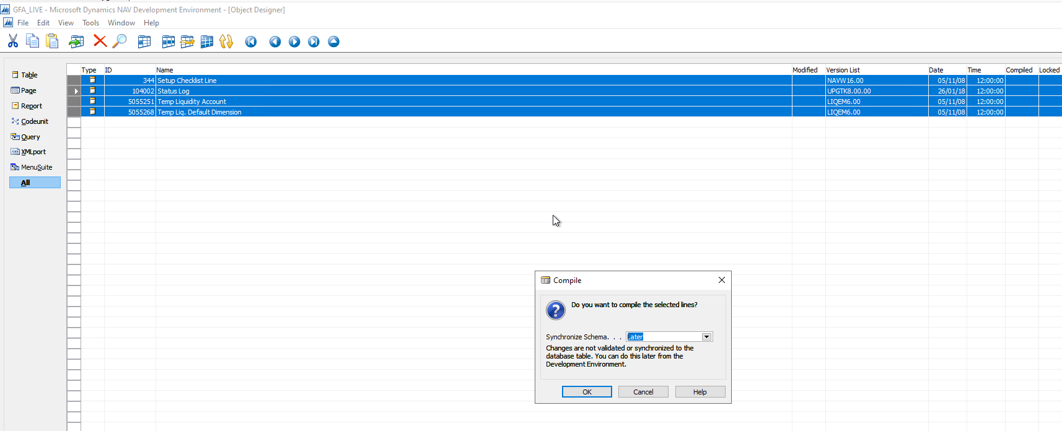

## Task 7: Run the Schema Synchronization

Similar to task 5, run the schema synchronization either from the development environment (Tools – Sync. Schema for All Tables – With Validation…) or from Microsoft Dynamics NAV 2015 Administration Shell.

This will synchronize the data schema changes of the newly imported tables to the SQL tables. It will also run the Upgrade Toolkit Step 1 logic if it is defined in the upgrade codeunit. This step will be performed for all companies in the database, so you don’t have to re-run it for other companies.

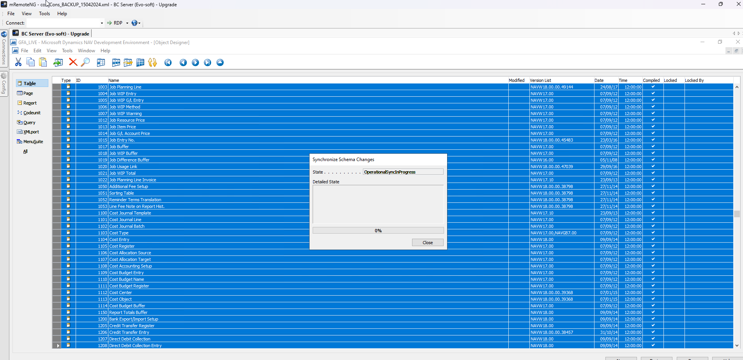

Note: After the synchronization schema has successfully completed, we strongly recommend that you take a full SQL Server backup of the database.

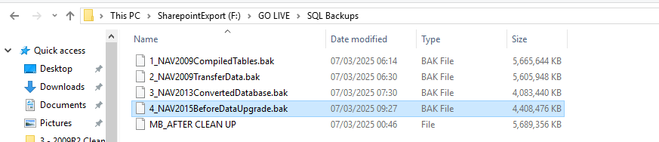

## Task 8: Run the Data Upgrade to perform Upgrade Toolkit Step 2

A data upgrade runs the upgrade toolkit objects, such as upgrade codeunits and upgrade tables, to migrate business data from the old table structure to the new table structure. You can start the data upgrade from the Microsoft Dynamics NAV Development Environment or Microsoft Dynamics NAV 2015 Administration Shell.

From the development environment:

* Open development environment as an administrator.
* On the Tools menu, choose Data Upgrade, and then choose Start and follow the instructions on the Start Data Upgrade window.

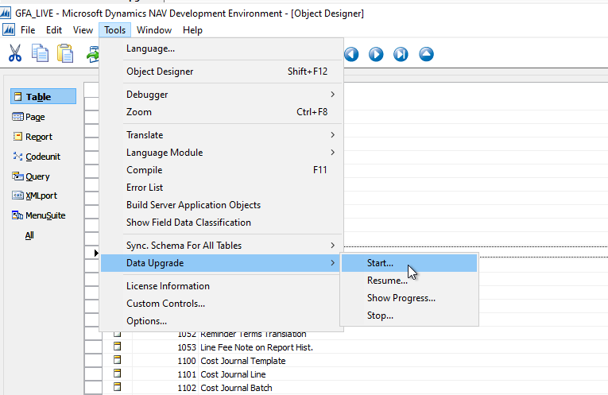

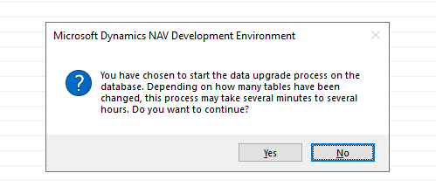

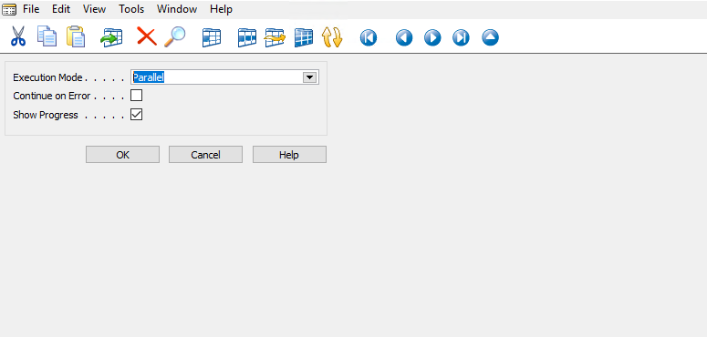

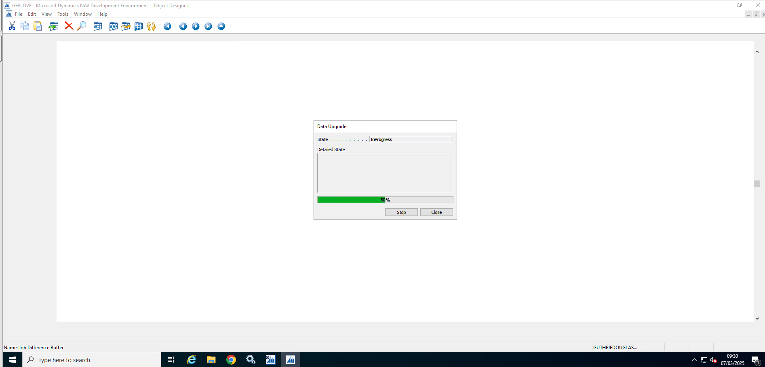

During this process there were 2 errors

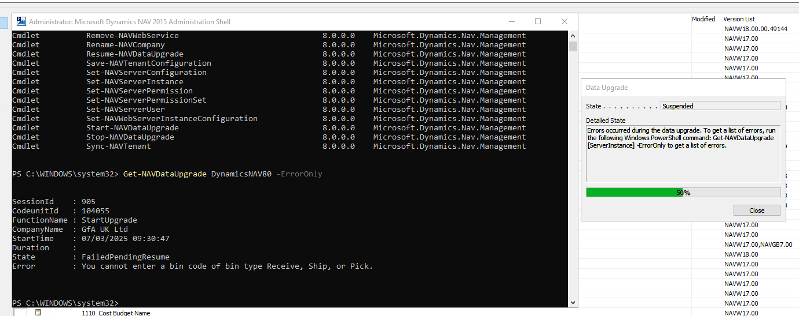

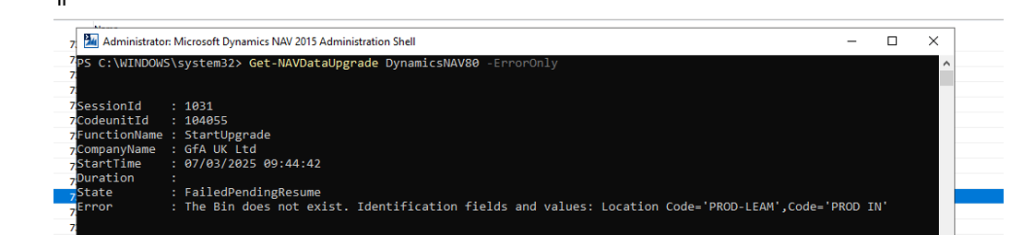

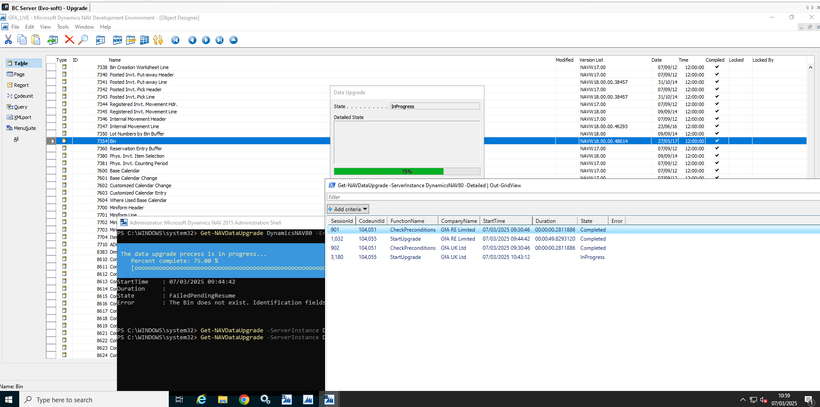

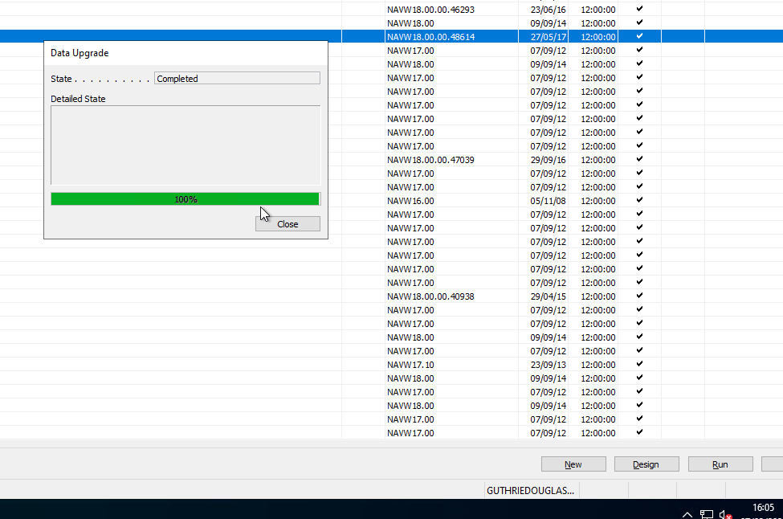

* If you want to see the result of running the Data Upgrade action, run the following cmdlet from Microsoft Dynamics NAV 2015 Administration Shell:

Get-NAVDataUpgrade -ServerInstance <ServerInstanceName> -Detailed | Out-GridView

In the output of this cmdlet, you can see which upgrade codeunits and functions were run, which companies have been upgraded, the time it took to run each upgrade function, and a detailed description of errors that occurred during the data upgrade.

If errors occurred while running the data upgrade, you can resolve them directly in the database (for example by updating the upgrade codeunits) and then resume the data upgrade. To resume the data upgrade, on the Tools menu, choose Data Upgrade, and then Resume.

Note: To optimize upgrade performance and effectively use the available computer resources, the data upgrade functions are executed in parallel and across all companies by default. While performing this step, if you discover that some functions are locking each other from executing, then you can configure the data upgrade to execute data upgrade functions in serial instead of parallel. To do this, on the Start Data Upgrade window, set the Execution Mode option to Serial.

From the Microsoft Dynamics NAV 2015 Administration Shell:

* Open the Microsoft Dynamics NAV 2015 Administration Shell as an administrator, and then run Start-NavDataUpgrade cmdlet as follows:
* Start-NavDataUpgrade -ServerInstance <ServerInstanceName> -Force
* Replace <ServerInstanceName> with the name of the Microsoft Dynamics NAV Server instance that is connected to the database.

To view the progress of the data upgrade, you can run Get-NavDataUpgrade cmdlet as follows:

Get-NAVDataUpgrade -ServerInstance <ServerInstanceName> -Progress

Note: The data upgrade process runs CheckPreconditions and Upgrade functions in the upgrade codeunits. If any of the preconditions are not met or an upgrade function fails, you must correct the error and resume the data upgrade process.

Backup Database

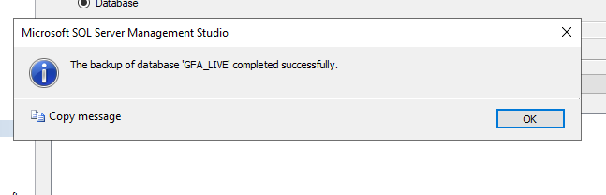

## Task 9: Delete the Upgrade Objects and Obsolete Tables

At this point, you have upgraded the database to Microsoft Dynamics NAV 2015. Now, you can delete the tables which are not needed into the new application, plus the upgrade codeunits and upgrade table objects that you imported in task 6.

For application tables, you can see which the tables are marked for deletion in the Version List column in the Tables list of Object Designer. During the data upgrade that you performed in task 8, these tables were marked with the text Old Unused Table – marked for deletion. Upgrade objects are marked with the text Upgrade Toolkit Object – marked for deletion.

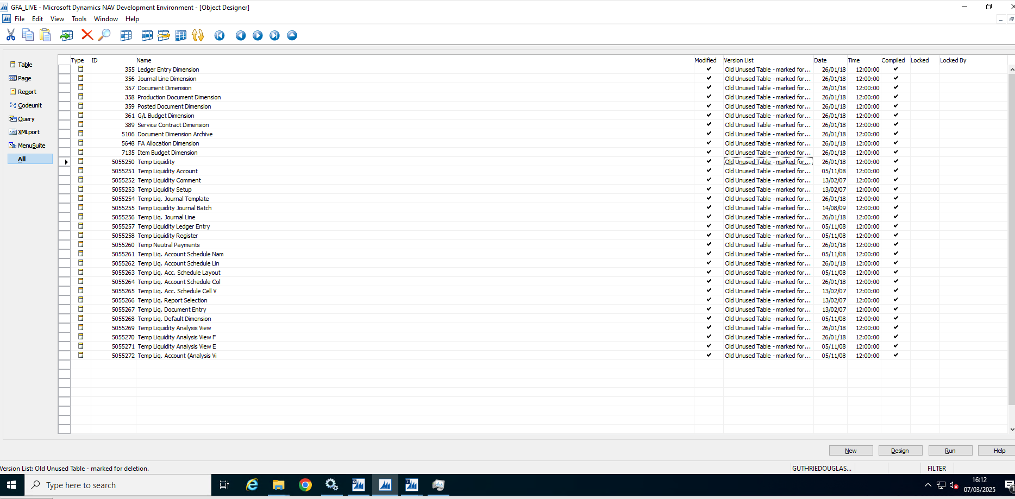

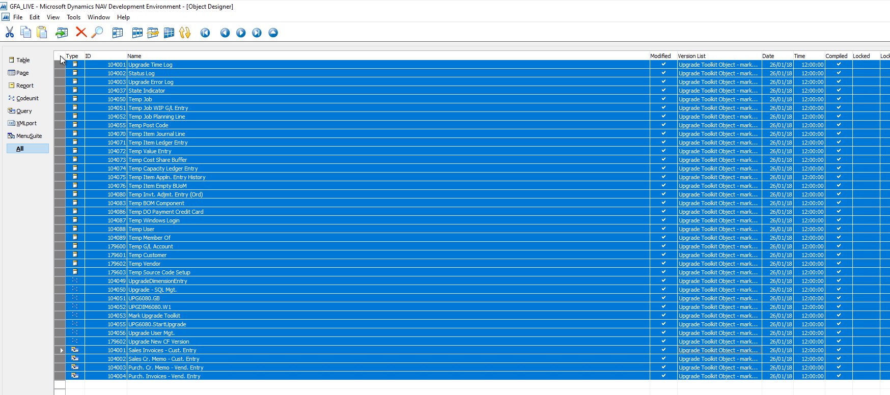Tas *After completing the NAV 2015 upgrade, ensure you get rid of any objects that should not be in the database. If you do not do this, the BC 14 upgrade will fail because some standard system table numbers are re-used in BC 14 and the schema sync will fail. There is a spreadsheet to assist with this in the Upgrade Resources in the same location as the Upgrade Toolkit for BC 14.*

## Task 10: Import upgraded permission sets and permissions by using the Roles and Permissions XMLports

You import the permission sets and permissions XML files according to the following procedure.

To import the permission sets and permissions

1. Delete all permission sets in the database except the SUPER permission set. In Object Designer, run page 9802 Permission Sets, and then delete the permission sets.

2. Run XMLport 9171 Import/Export Permission Sets to import the permission sets XML file.

In the request page for the XMLport, in the Direction field, choose Import, choose the OK button, and then specify the permission sets XML file.

3. Run XMLport 9172 Import/Export Permissions to import the permission XML file.

In the request page for the XMLport, in the Direction field, choose Import, choose the OK button, and then specify the permissions XML file.

## Task 11: Set the Language of the Customer Database

In the development environment, choose Tools, choose Language, and then select the language of the original customer database.

## Task 12: Add New Control Add-ins

N/A

# NAV 2015 to BC14

## [Document](https://learn.microsoft.com/en-us/dynamics365/business-central/dev-itpro/upgrade/upgrading-the-data)

There is no need to proceed past point 12 as you will be upgrading to BC 23 directly afterwards and therefore symbols do not need generating and apps do not need installing. The Upgrade Toolkit can be found in the Upgrade Resources. Warning: The “GfA Performance Change to Upgrade80014x.GB.fob” file must be applied after importing the Upgrade Toolkit to disable upgrade of Item Category Codes, otherwise the data upgrade will take over 40 hours. I strongly recommend checking the UpgradeItem routine in the UPG.GB codeunit has the code to upgrade item categories remarked out before starting the data upgrade.



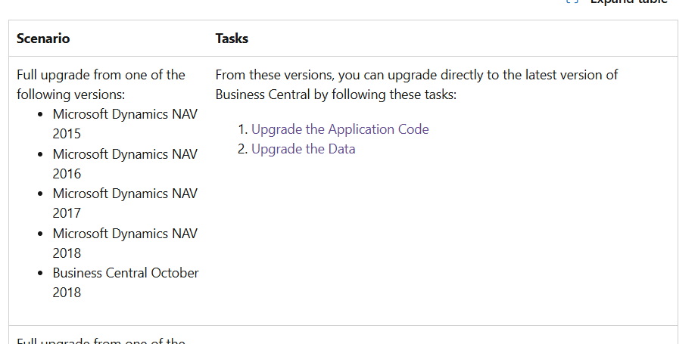

**About Data Upgrade**

You use data conversion tools provided with Business Central to convert the old data with the old version's table and field structure, so that it functions together with the new version's table and field structure. Mainly, only table objects and table data are modified during the data upgrade process. Other objects, such as pages, reports, codeunits, and XMLports are upgraded as part of the application code upgrade process.

The data upgrade process described in this article leads you through the database conversion (technical upgrade) and then the upgrade of the actual data, which is achieved by using the upgrade toolkit/upgrade codeunits.

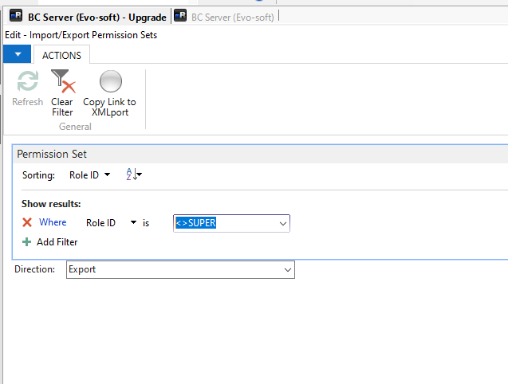



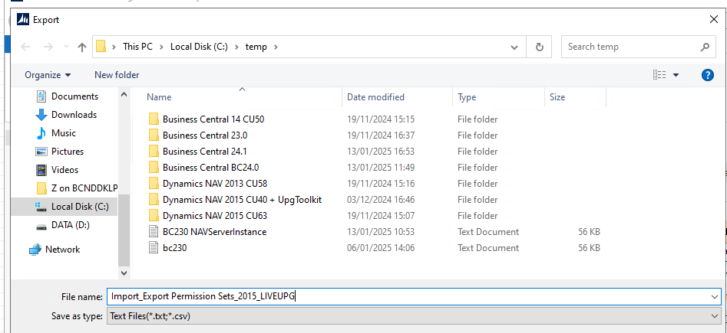

## Task 1: Create full SQL backup of old database

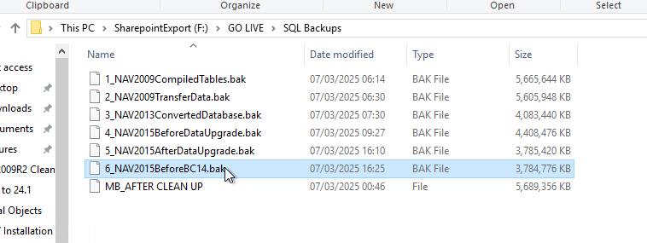

## Task 2 Uninstall all extensions in old database

Not applicable

## Task 3: Upload Business Central partner license to old database

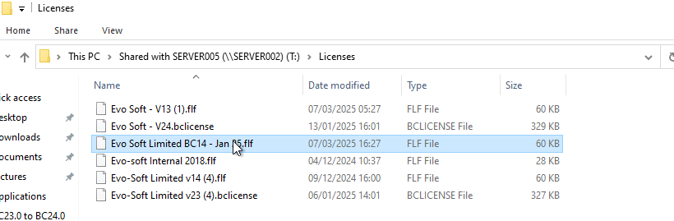

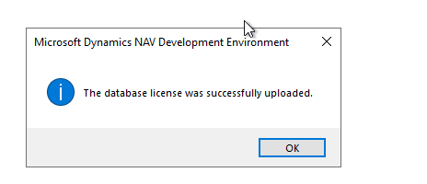

## Task 4: Delete all objects except tables in old database

In the development environment version that matches the database, open the old database, open Object Designer, select all objects except tables, and then choose **Delete**.

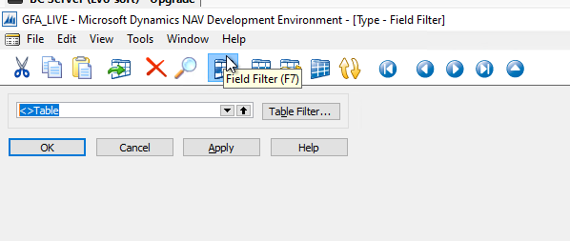

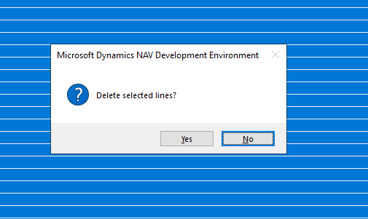

## Task 5: Clear server instance and debugger breakpoint records in old database

## Clear all records from the dbo.Server Instance and dbo.Debugger Breakpoint tables in the database in SQL Server.

## Make sure that you stop the old server instance, and close any tools that connect to the database, such as the Dynamics NAV Administration Tool and development environment.

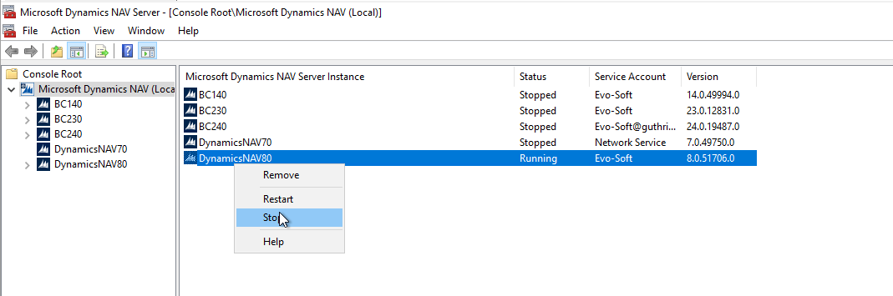

## Using SQL Server Management Studio, open and clear the dbo.Server Instance and dbo.Debugger Breakpoint tables of the old database. For example, you can run the following SQL query:

## DELETE FROM [<My NAV Database Name>].[dbo].[Server Instance]

## DELETE FROM [<My NAV Database Name>].[dbo].[Debugger Breakpoint]

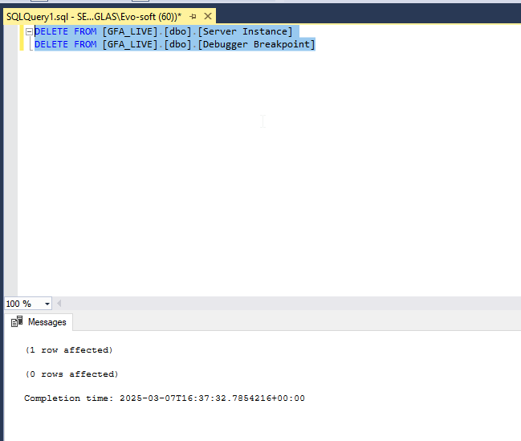

## Task 6: Convert old database to Business Central (Run as administrator)

To convert the old database to the Business Central format, run the new Dynamics NAV Development Environment for Business Central, open the old database, and follow the conversion instructions.

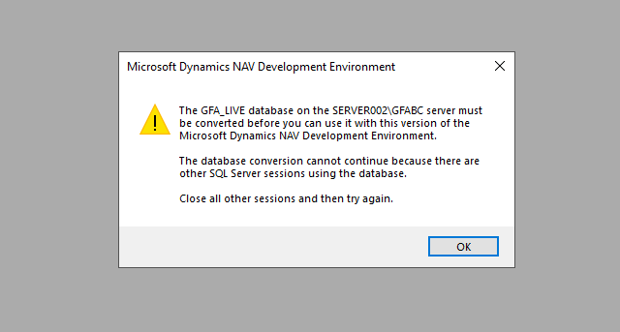

Make sure to close all related sessions

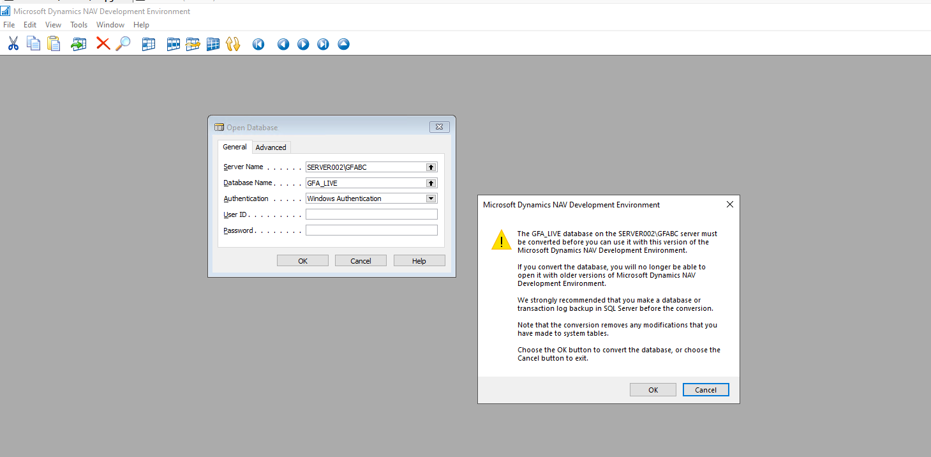

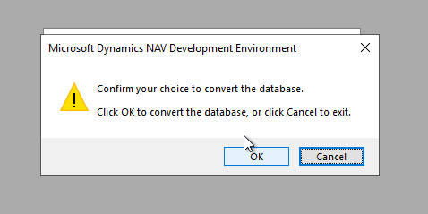

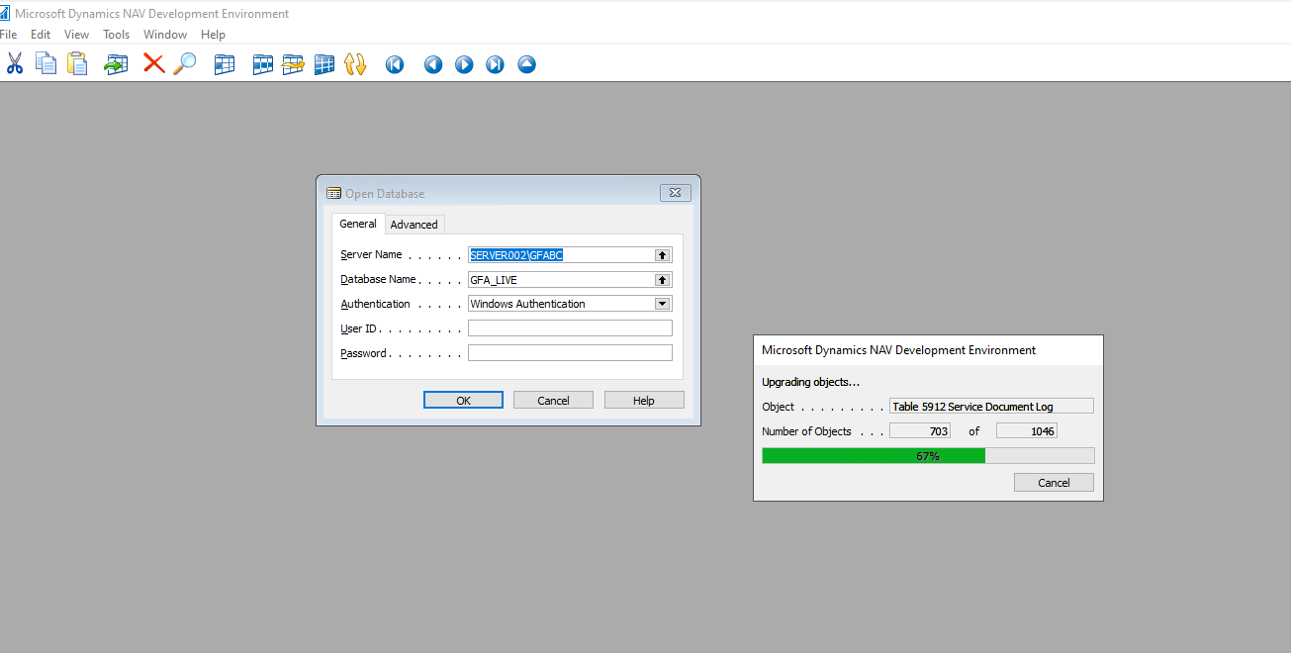

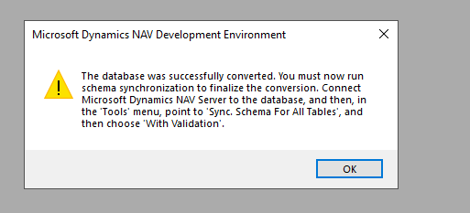

If you do not run the development environment as an administrator, you will get an error and the conversion will be stopped.

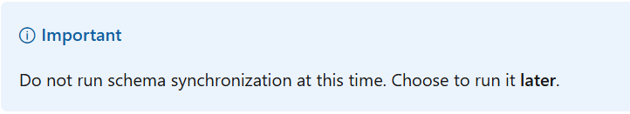

## Task 7: Import upgraded application objects to converted database

## Task 8: Connect a Business Central Server instance to converted database

Use BC Administration to connect database to BC service tier and ensure ‘Enable loading application symbol references at server start-up is enabled in the Development tab.

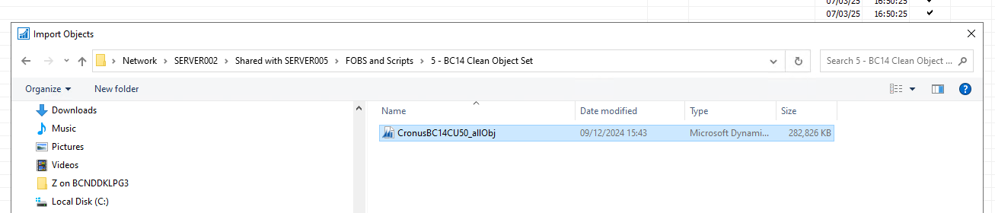

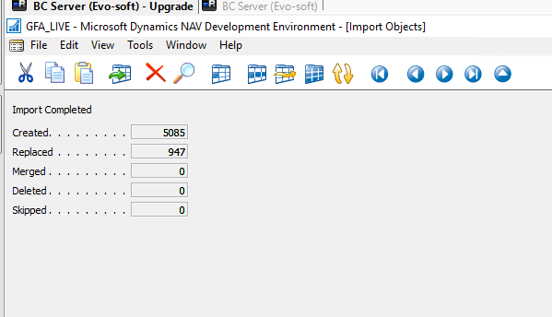

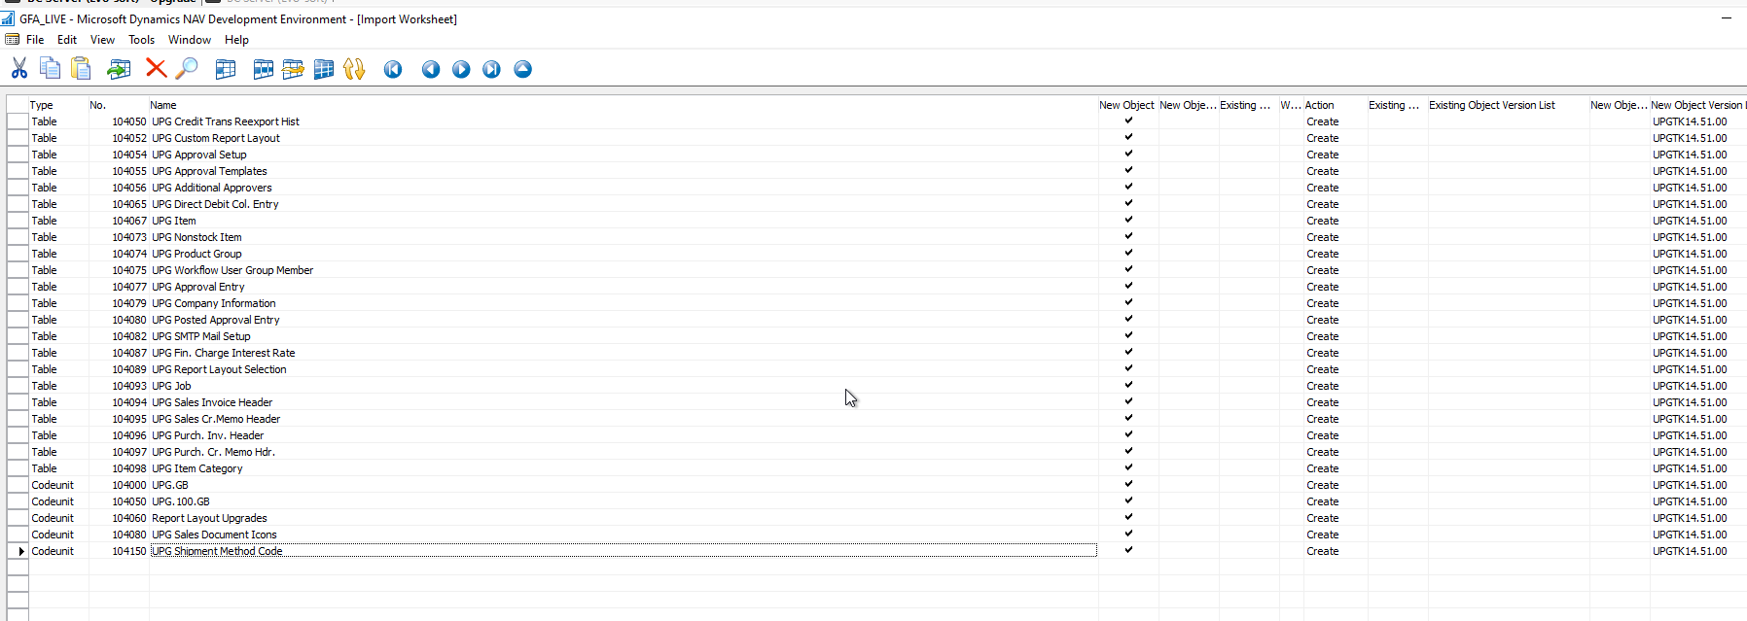

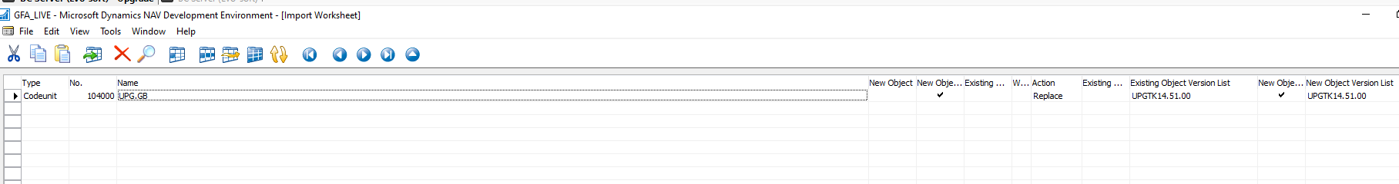

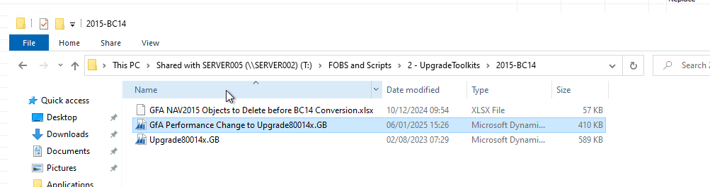

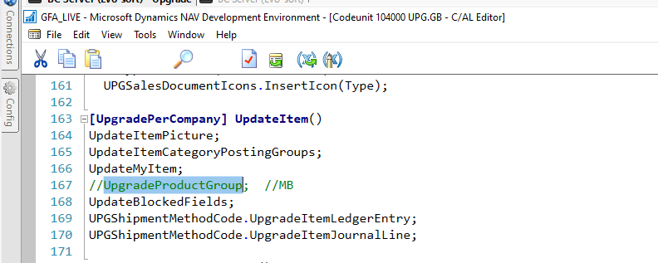

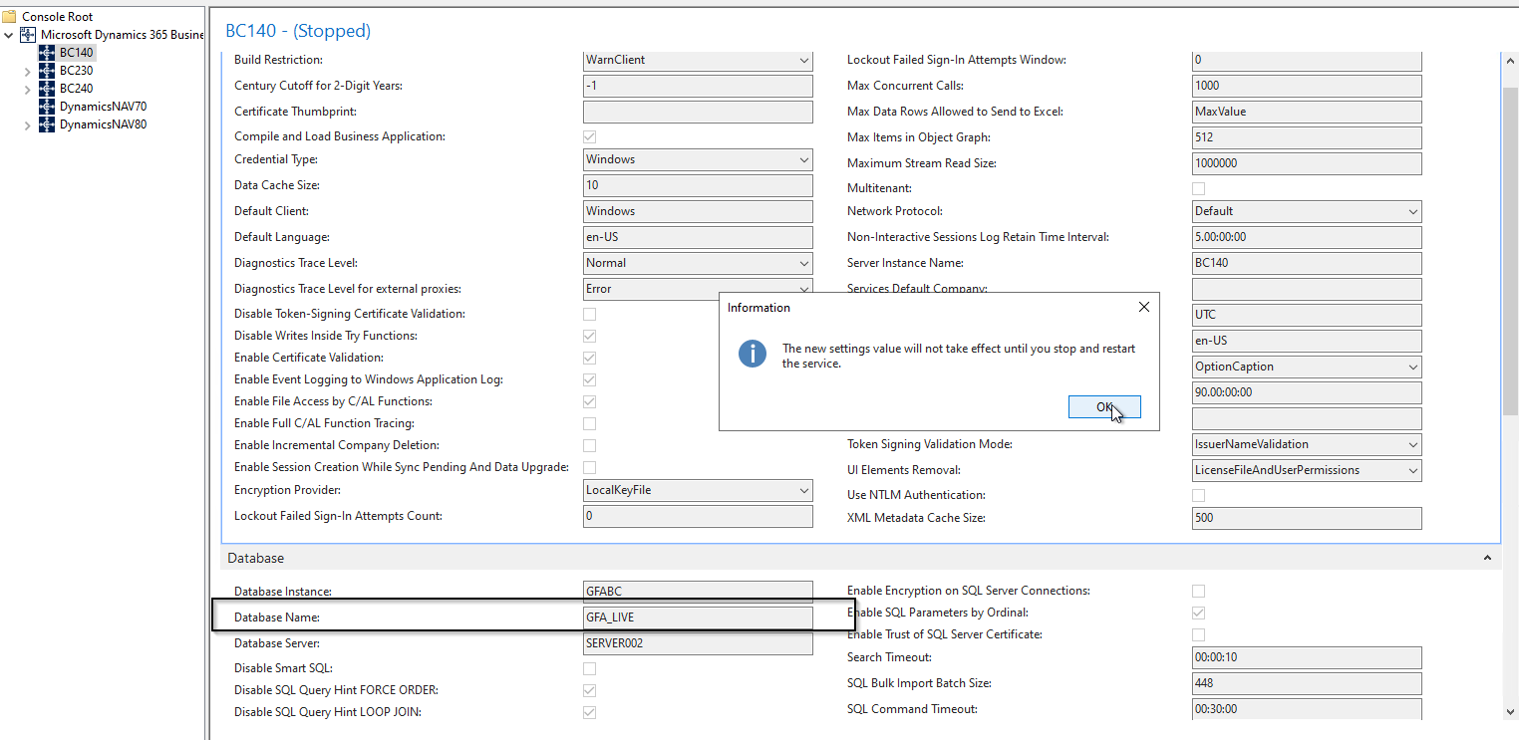

Delete Custom Tables (not sync the schema)

## Task 9: Compile all objects in converted database

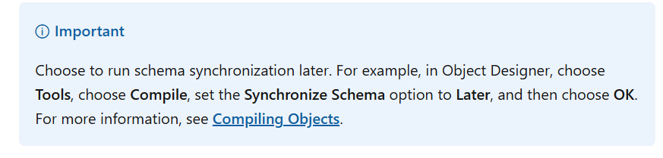

"Delete the following tables (Force)

Table 470 Job Queue (replaced by the Task Scheduler)

Table 824 DO Payment Connection Details

Table 825 DO Payment Connection Setup

Table 827 DO Payment Credit Card

Table 828 DO Payment Credit Card Number

Table 829 DO Payment Trans. Log Entry

Table 1510 Notification Template

470|824|825|827|828|829|1510

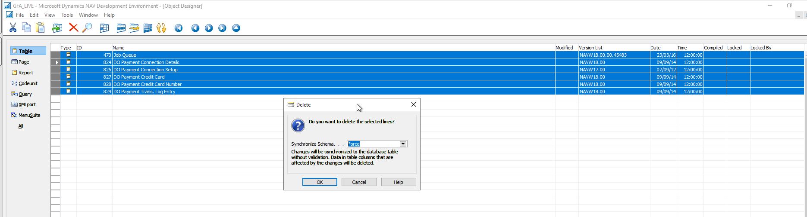

Delete also the old objects

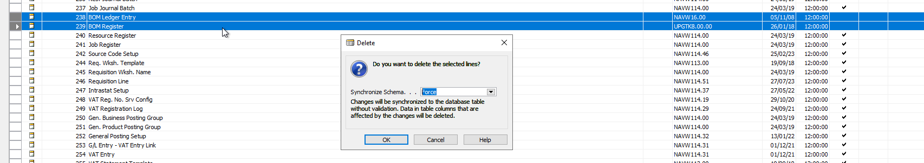

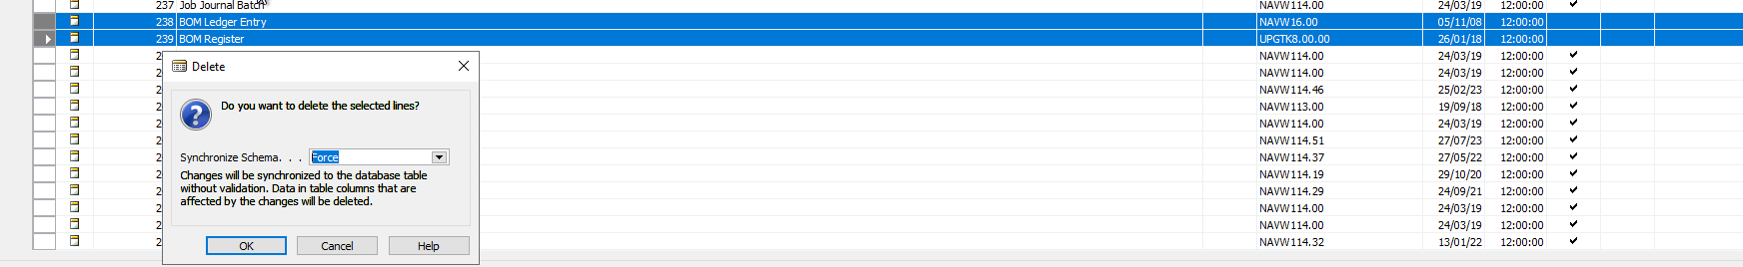

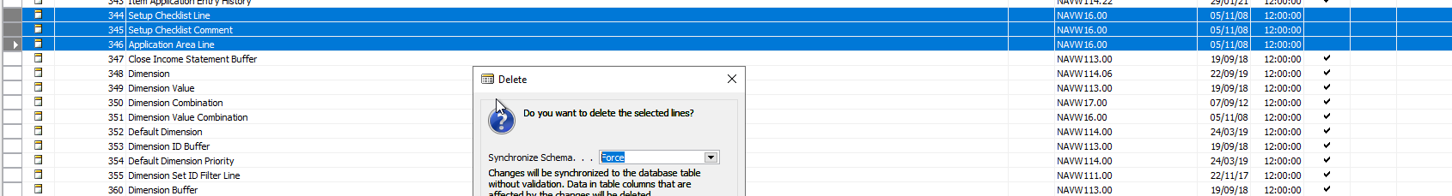

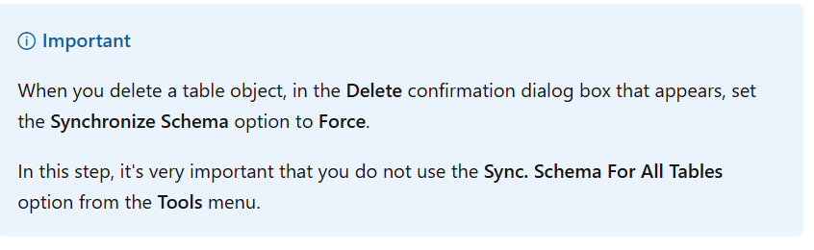

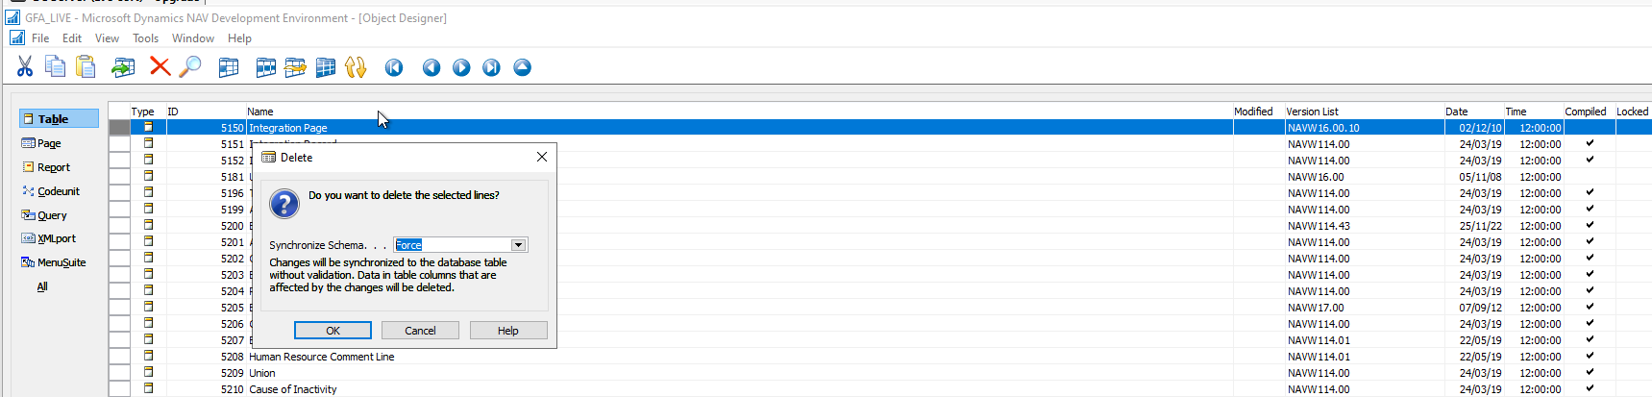

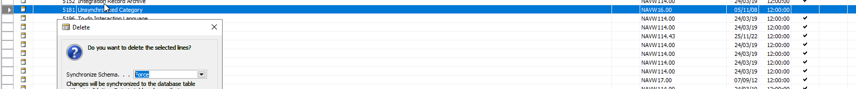

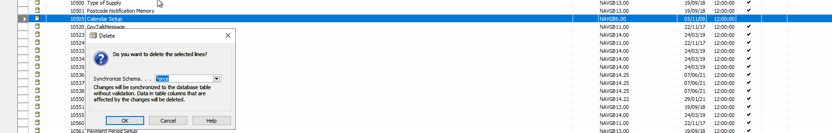

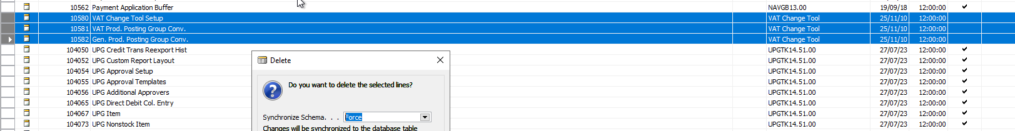

## Task 10: (Upgrade from Dynamics NAV 2018 or Business Central Fall 2018 only ) Increase the application version of converted database

Not applicable

**Task 11: Run the schema synchronization on converted database**

Sync-NAVTenant -ServerInstance <ServerInstanceName>

N/A

When completed, the tenant (database) should have the status OperationalDataUpgradePending. To verify this, run the following cmdlet:

Get-NAVTenant -ServerInstance <ServerInstanceName> -tenant default

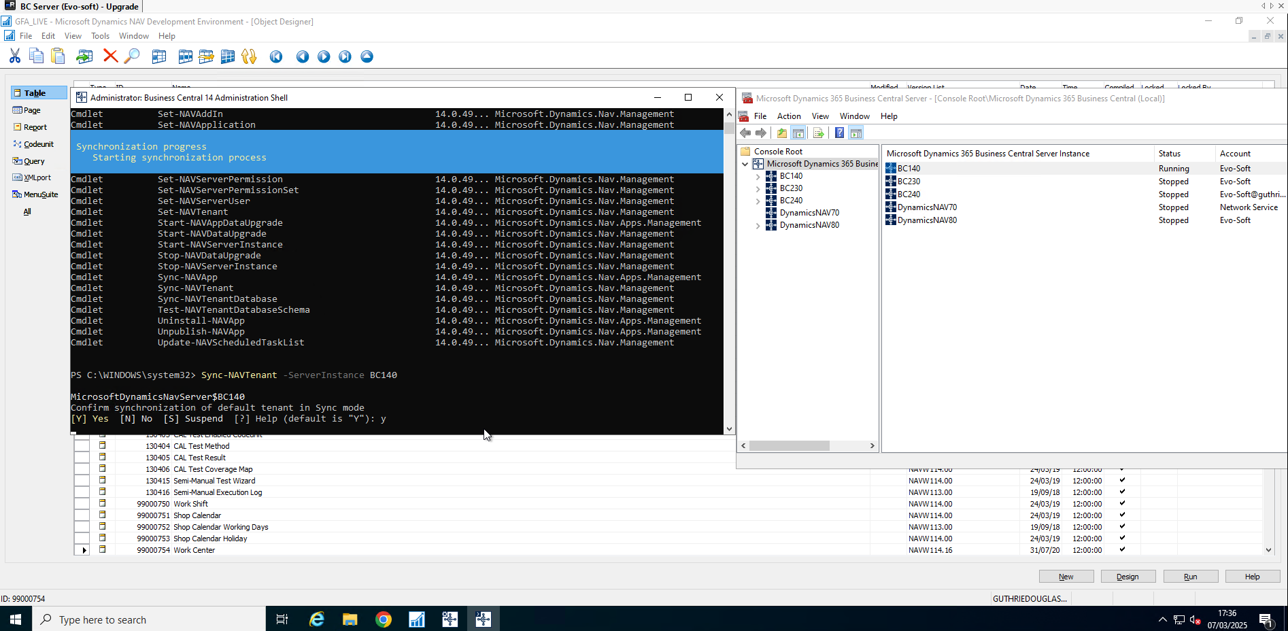

Backup database

**Task 12: Run data upgrade on converted database**

Start-NavDataUpgrade -ServerInstance BC140 -FunctionExecutionMode Serial

Check progress

Get-NAVDataUpgrade - Progress

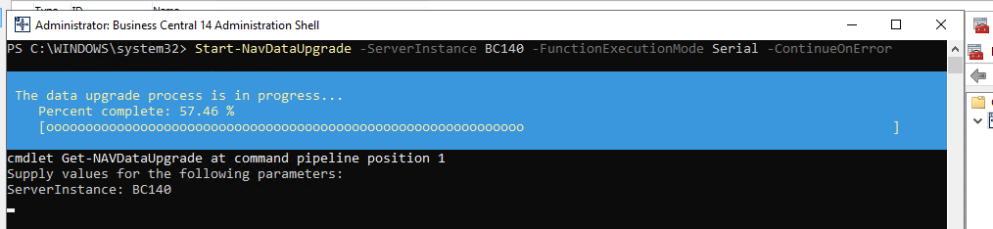

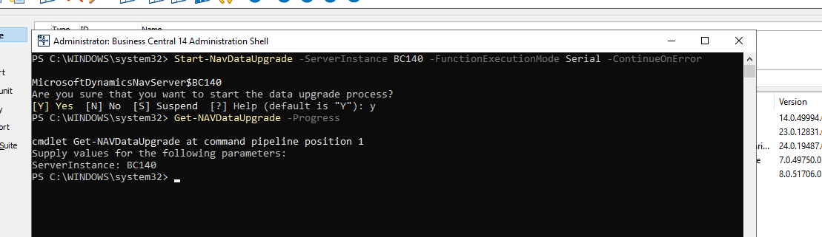

Get-NAVDataUpgrade -ServerInstance <ServerInstanceName> -ErrorOnly

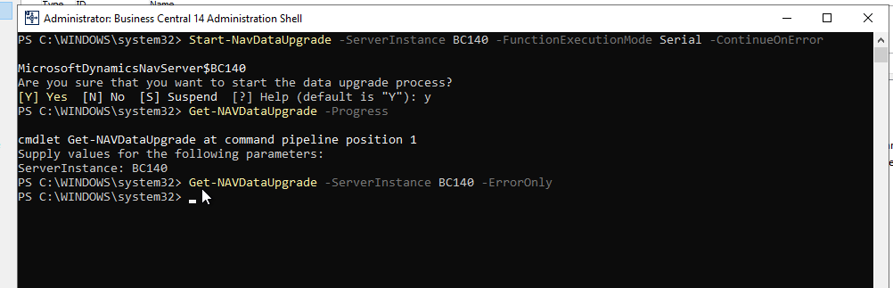

Backup database

**Task 13: Upgrade Javascript-based control add-ins to new versions**

N/A

**Task 14: Publish and generate symbols for extensions**

N/A

**Task 15: Upgrade or repair V2 extensions**

N/A

**Task 16: Publish and install local functionality extensions**

N/A

**Task 18: (Optional) Import data encryption key**

N/A

**Task 19: Set the language of customer database**

N/A

**Task 20: (Optional) Update Web Server instance configuration file**

**(Optional) Task 21: Delete upgrade objects**

**BACKUP**

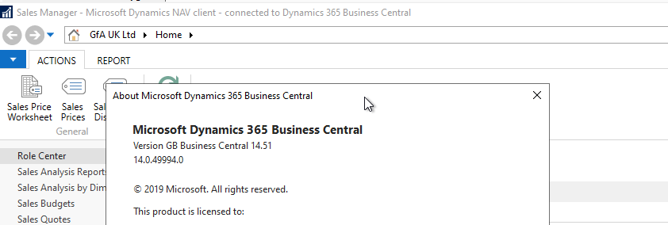

# BC14.51 to BC23.0

**Backup**

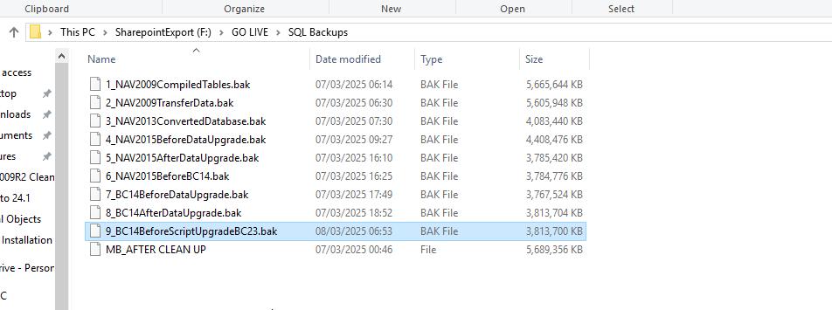

## Script 1

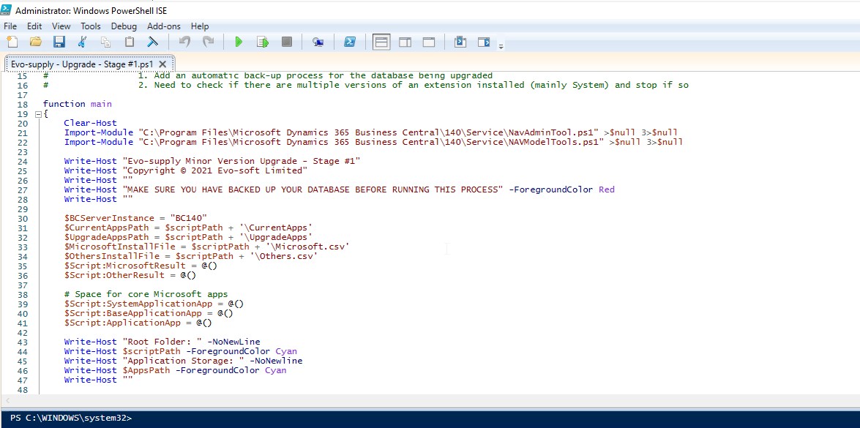

Stage 1 will do little, aside from a couple of errors, since there are no apps or symbols in the database to unpublish. It is still required to create the csv files that stage 2 uses.

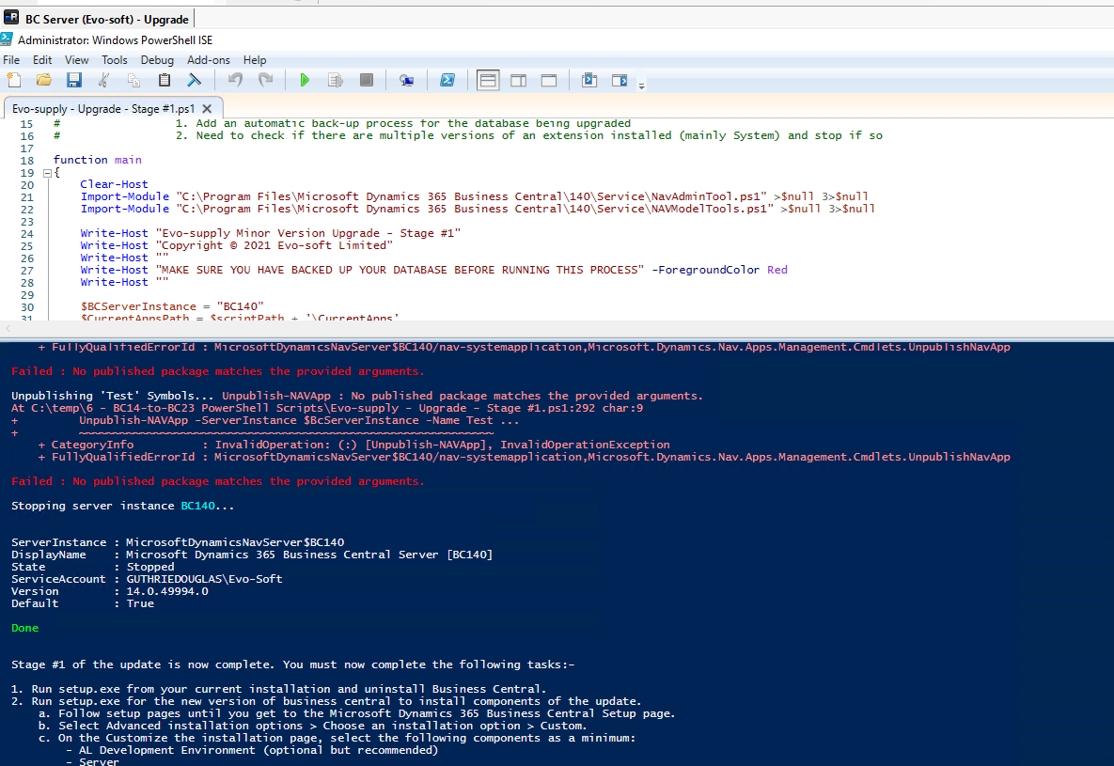

## Script 2

Close and reopen ISE(Run as administrator) to load the Module for BC23

Edit the script to point to the new database.

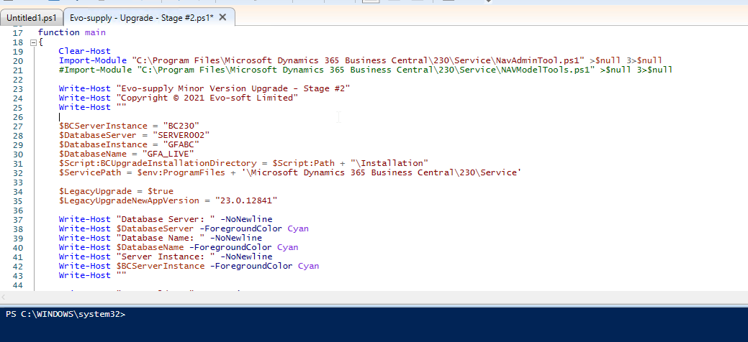

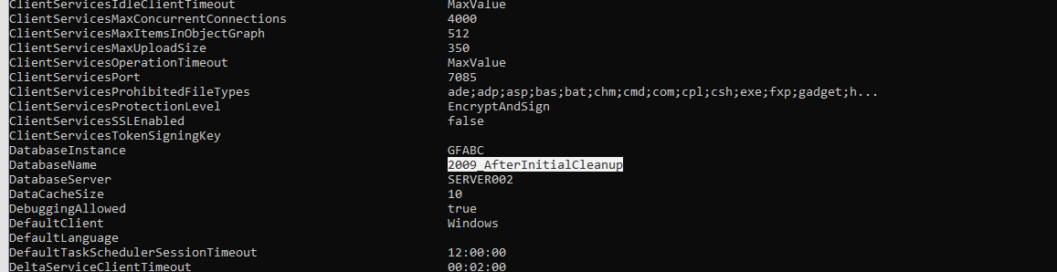



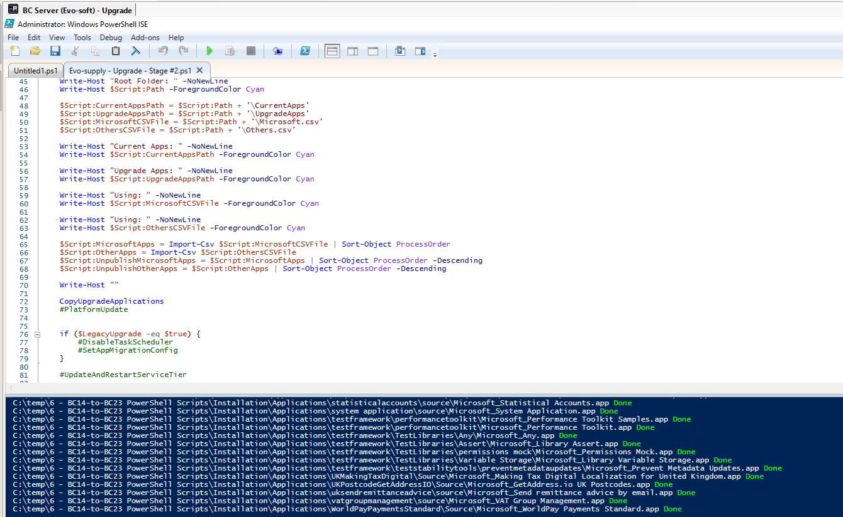

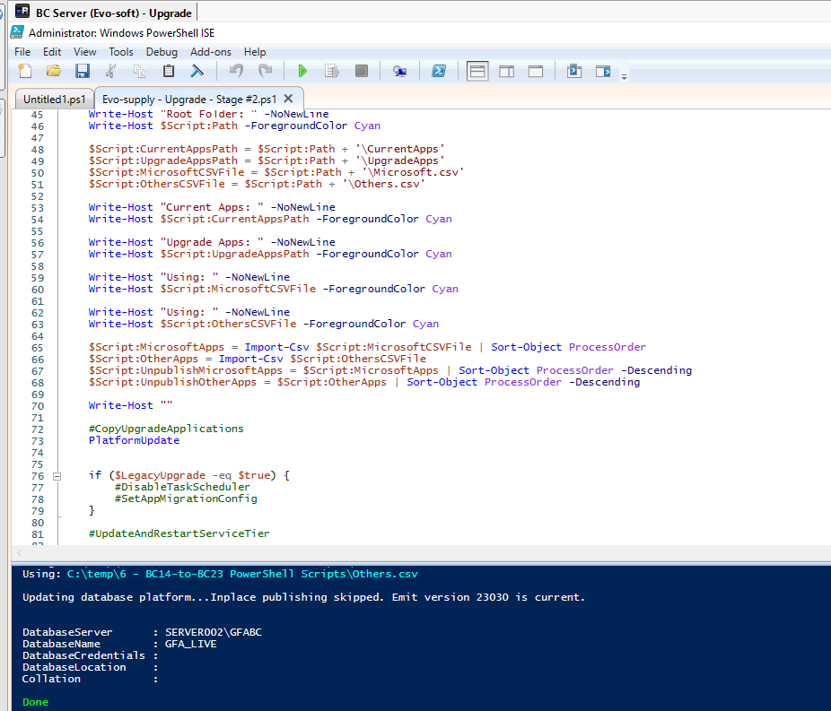

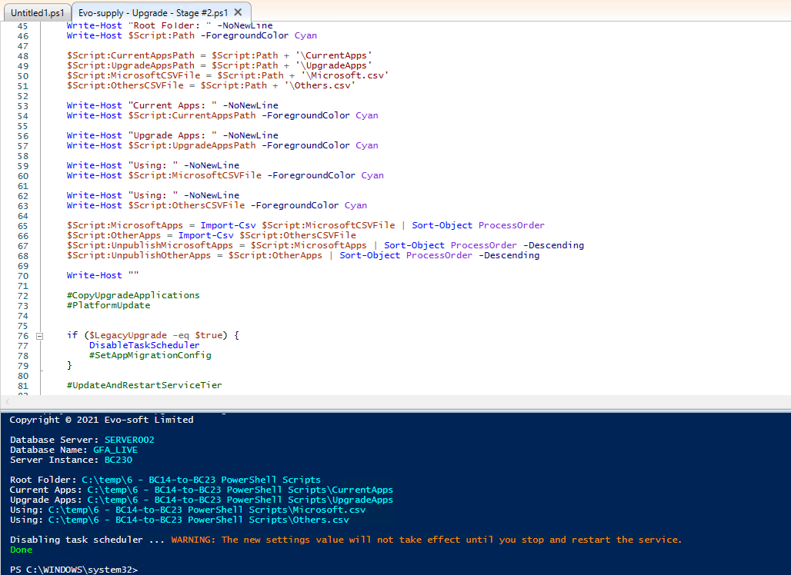

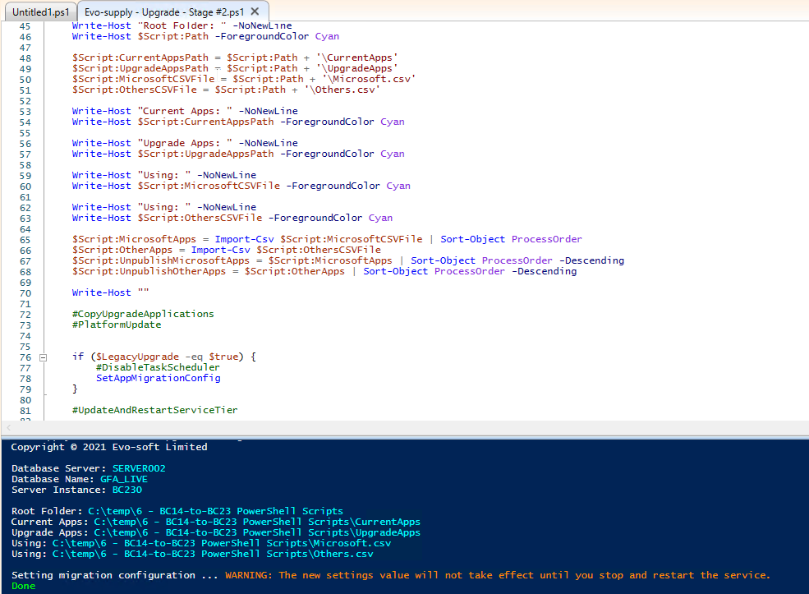

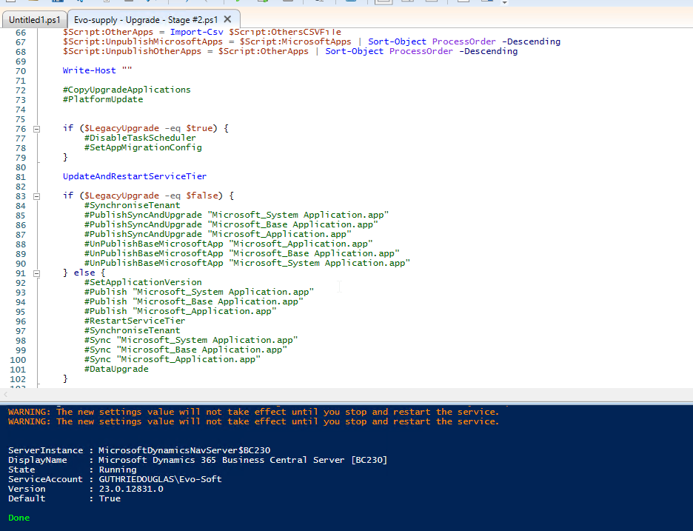

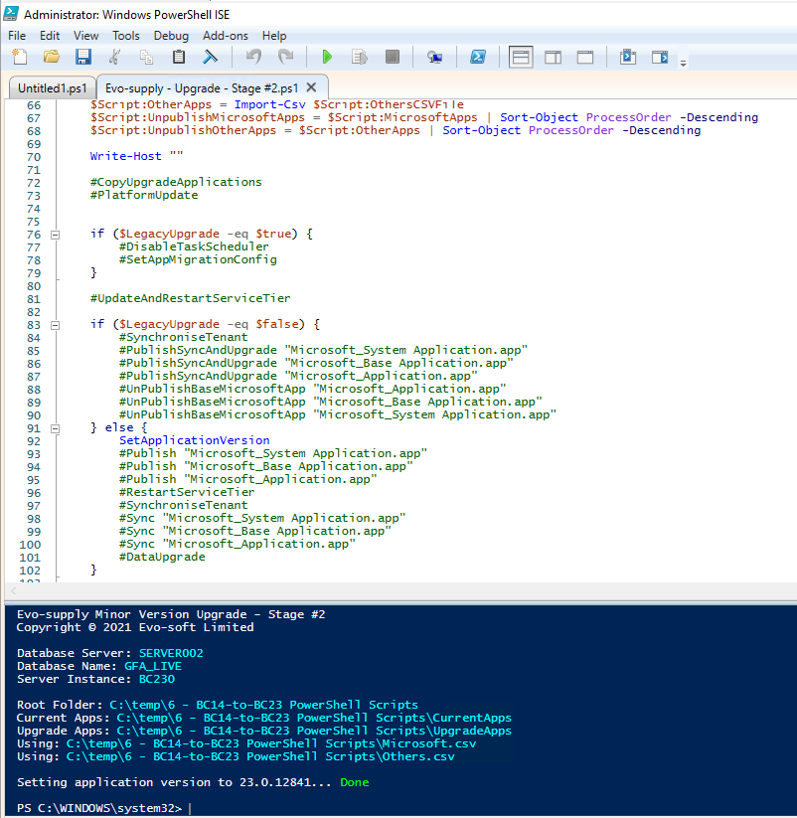

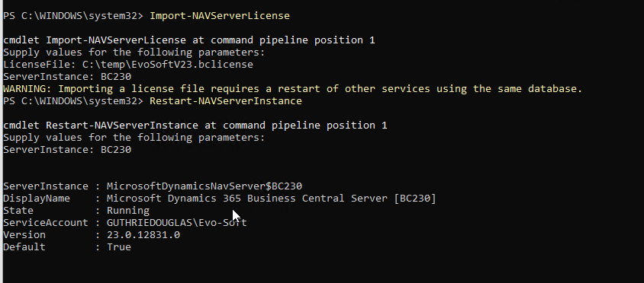

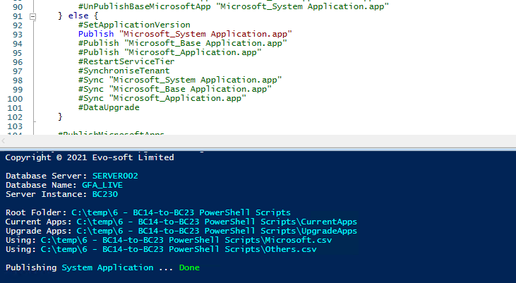

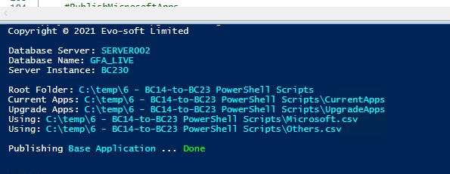

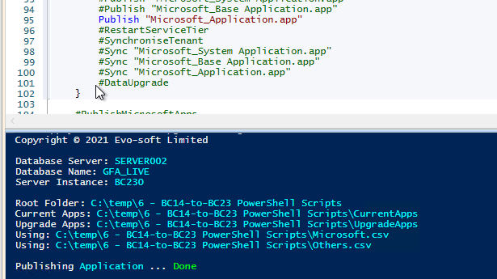

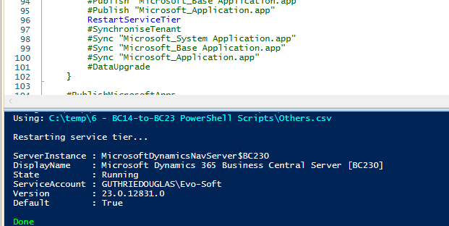

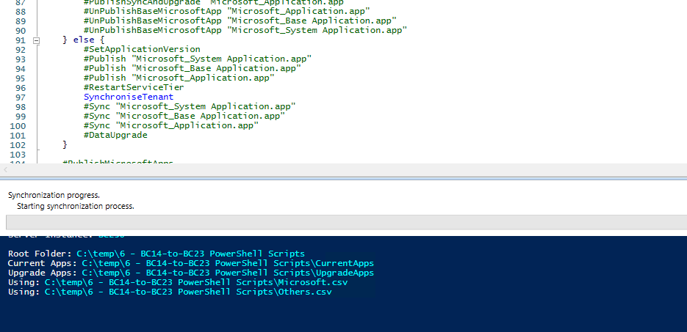

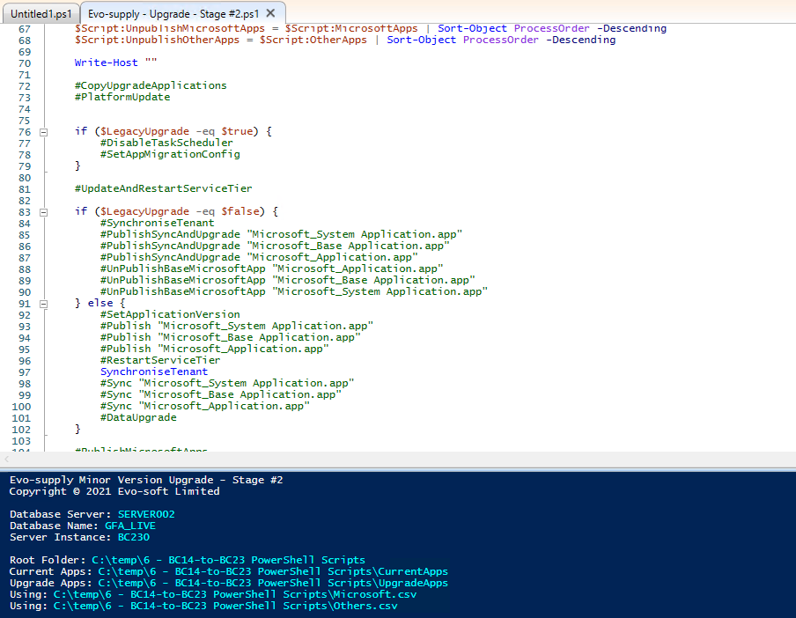

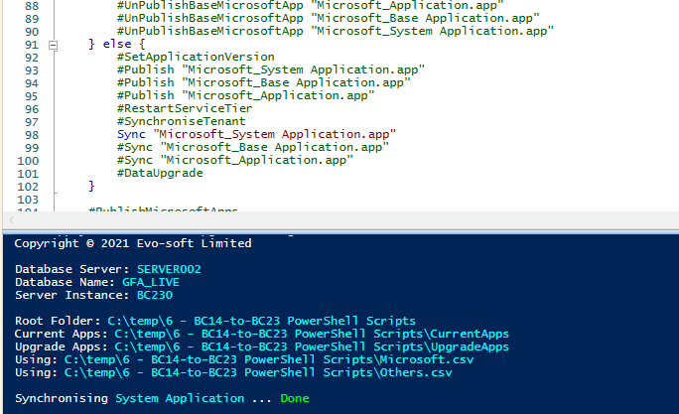

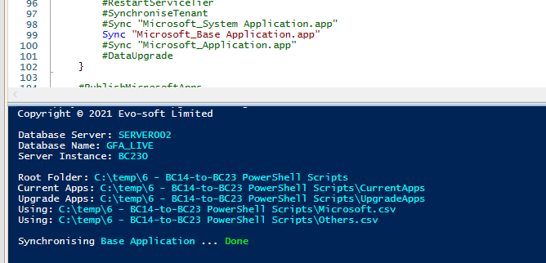

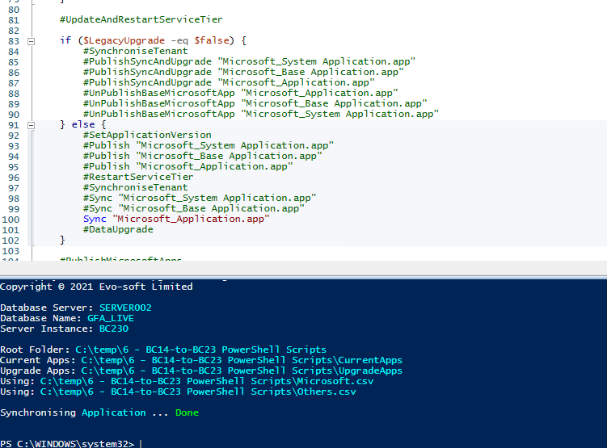

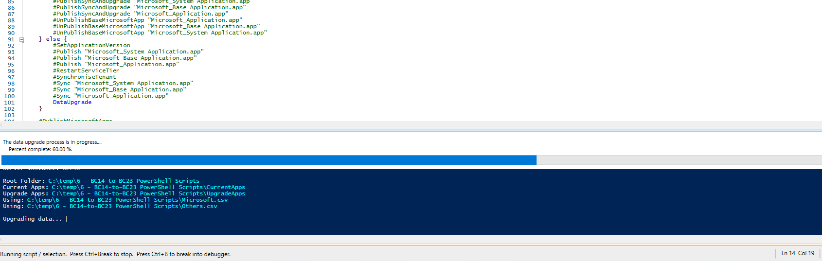

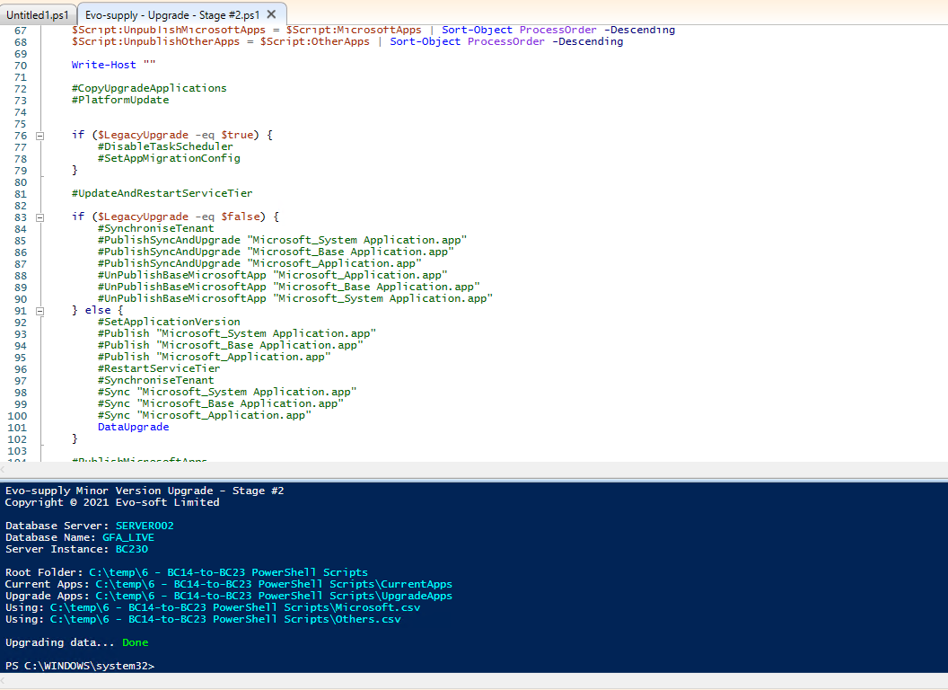

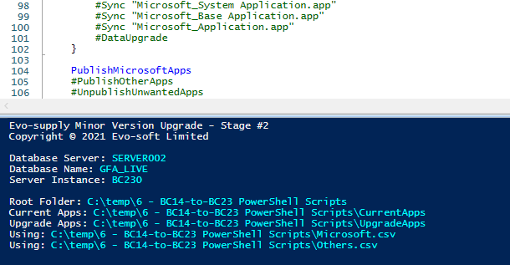

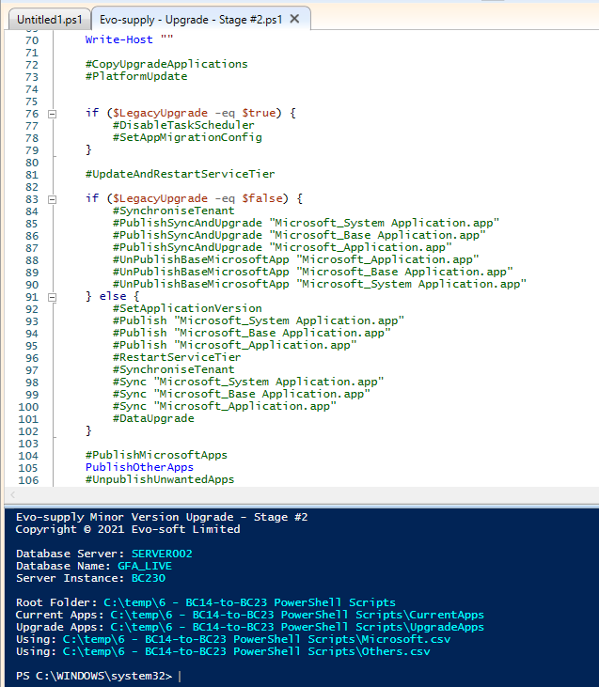

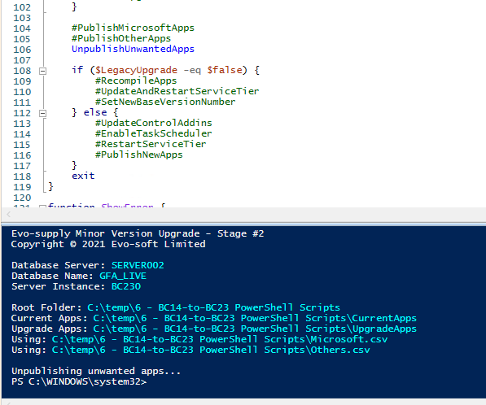

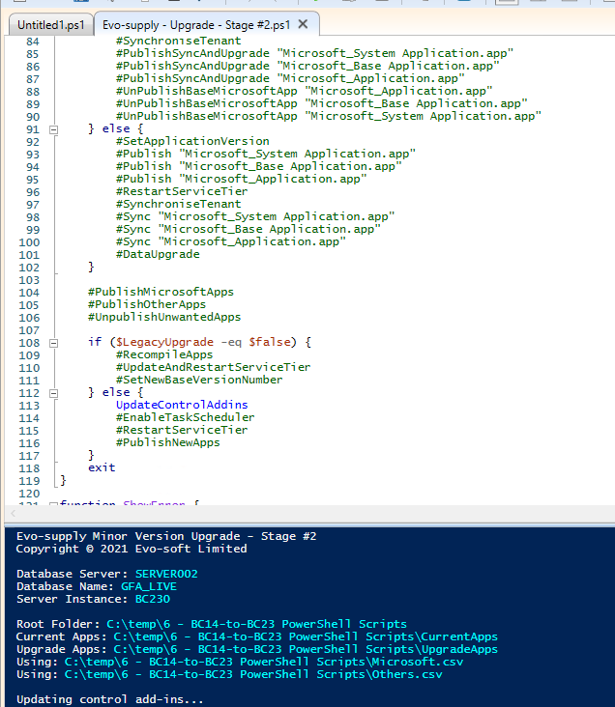

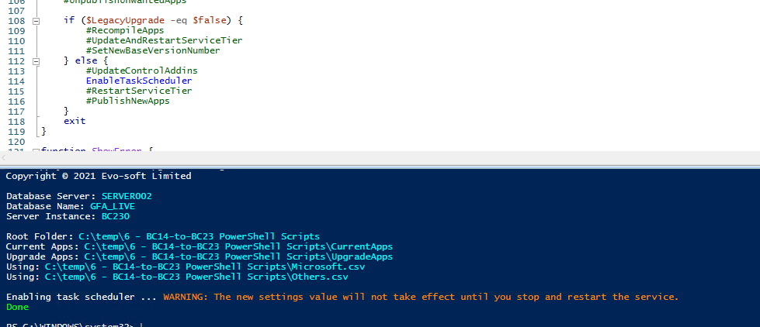

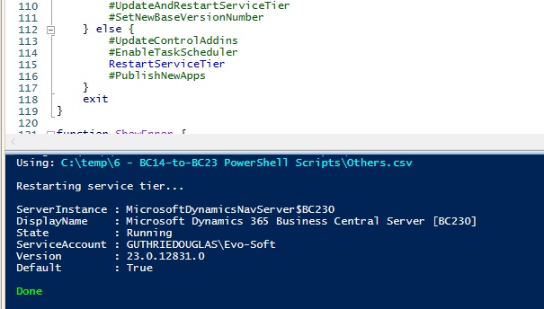

Backup

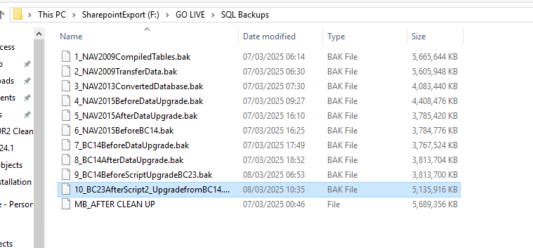

Shrink Log

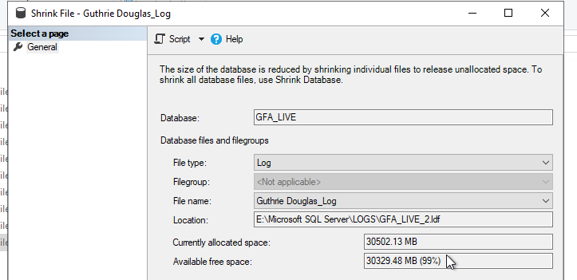

# BC23.0 to BC24.1

## In the GO Live we choose to upgrade BC23.0 directly to BC24.1 final version

## Script 1

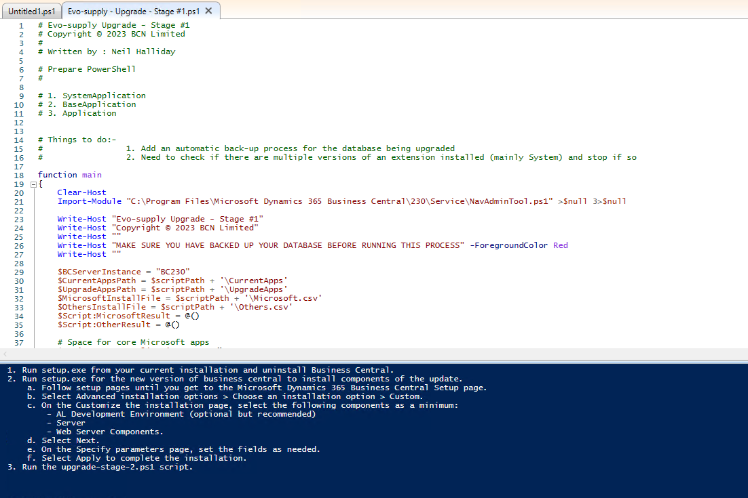

## Script 2

Close and reopen ISE(Run as administrator) to load the Module for BC24

Edit the script to point to the new database and to the most recent dev. License

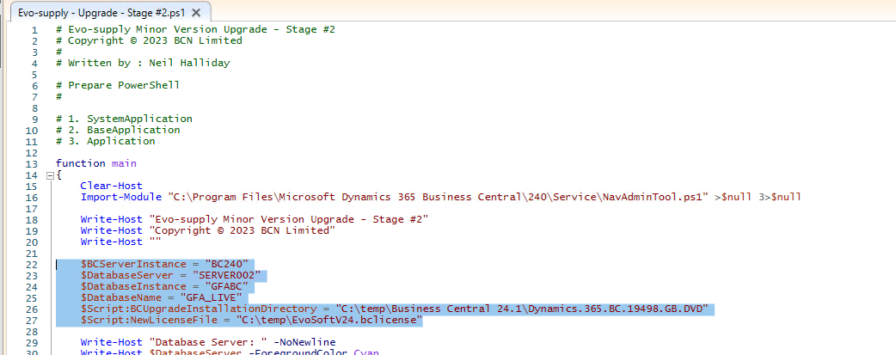

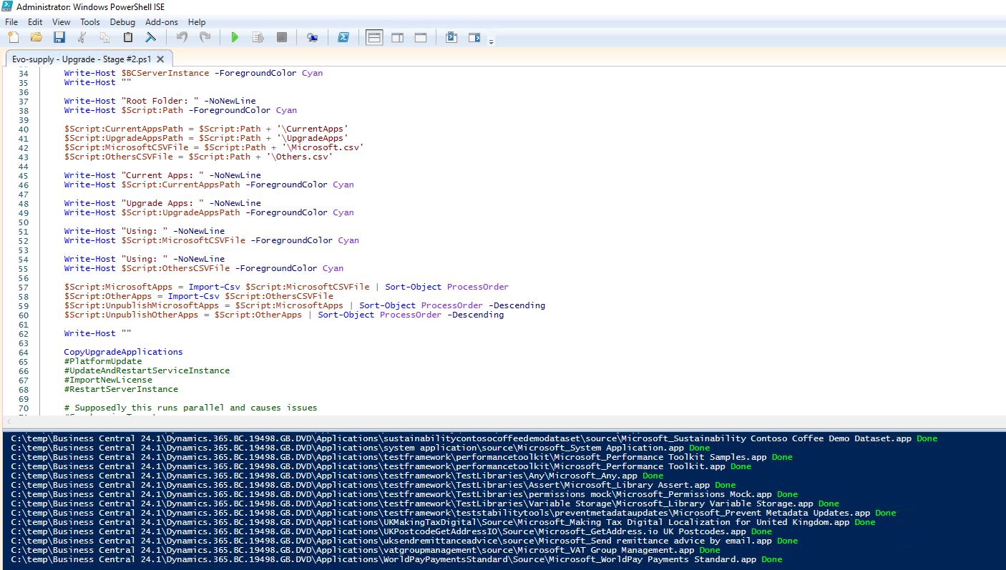

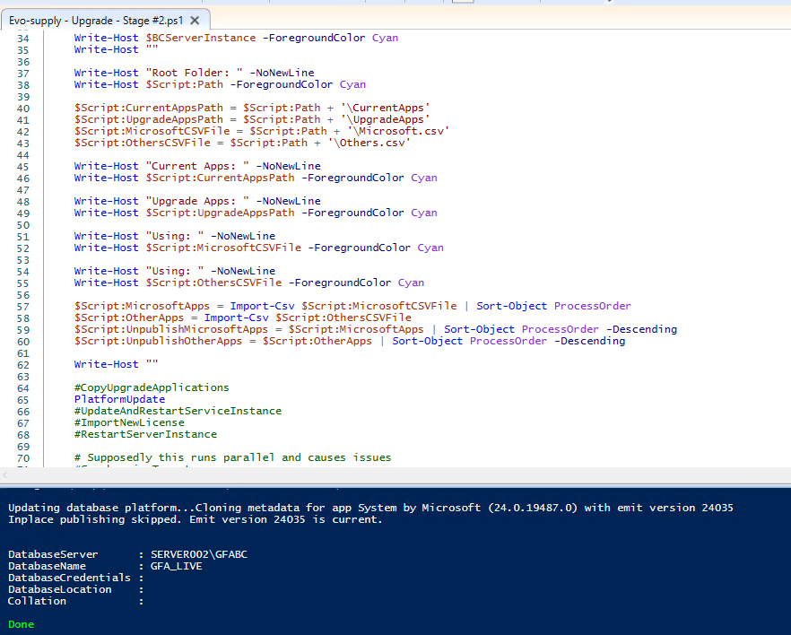

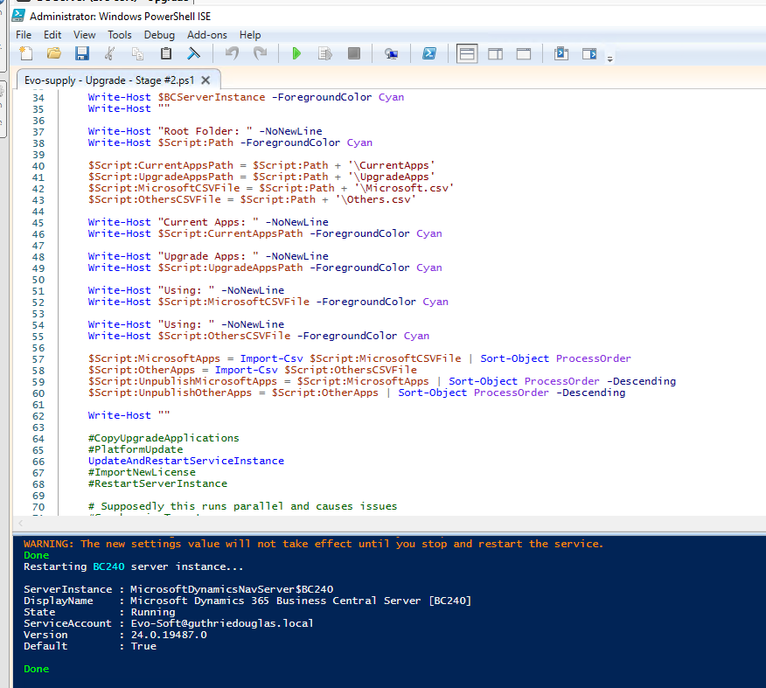

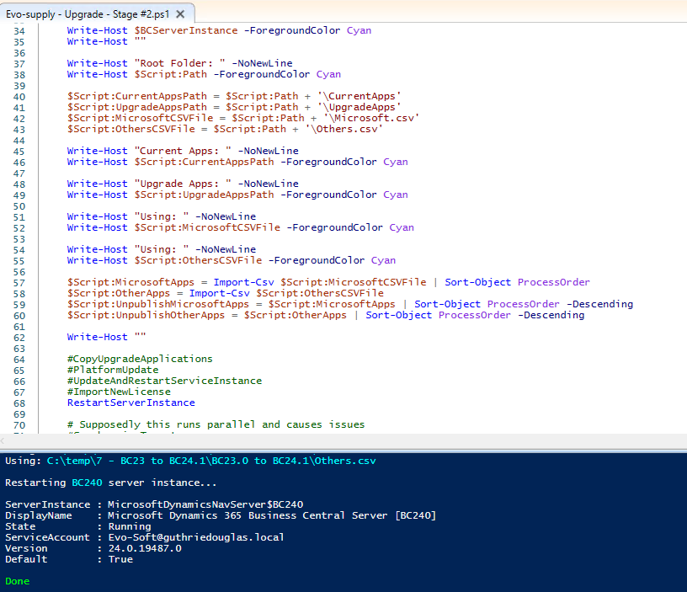

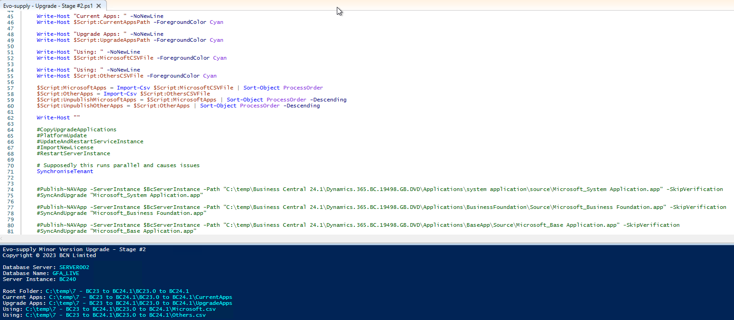

PublishSyncUpgrade - System Application - if you cannot in one go and then do the publish/sync/upgrade as below

Publish Business Foundation

Publish Base Application

Publish Application

Sync Business Foundation

Sync Base Application

Sync Application

Upgrade System Application

Install Business Foundation

Upgrade Base Application

Upgrade Application

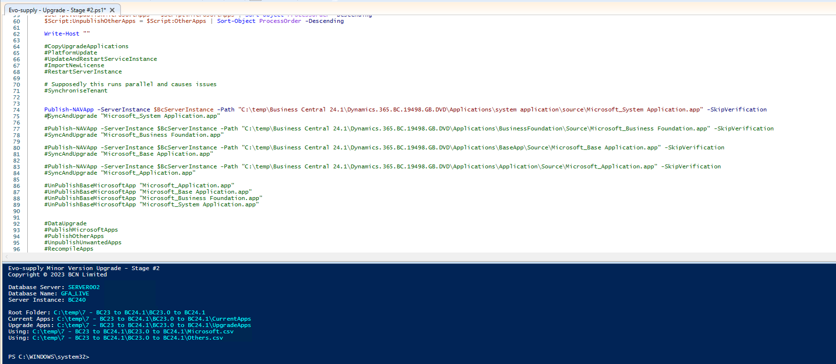

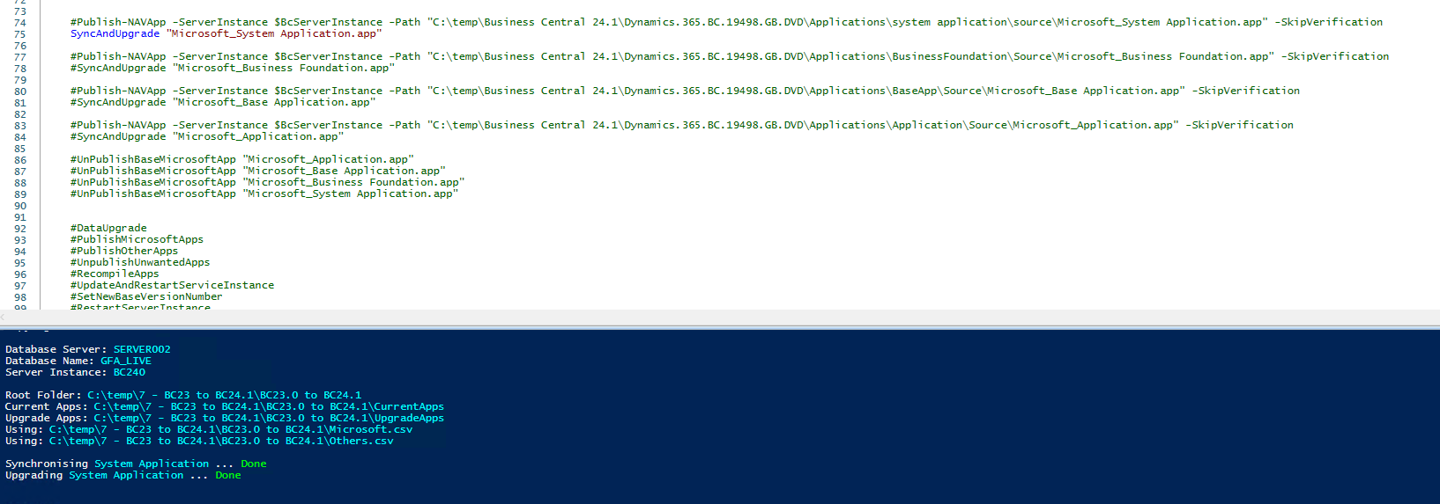

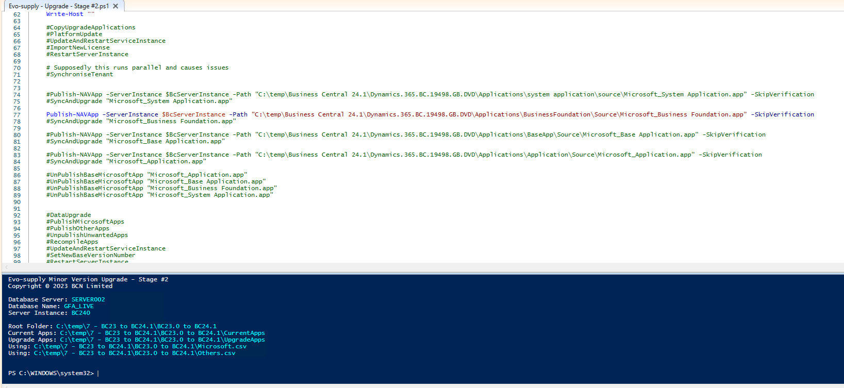

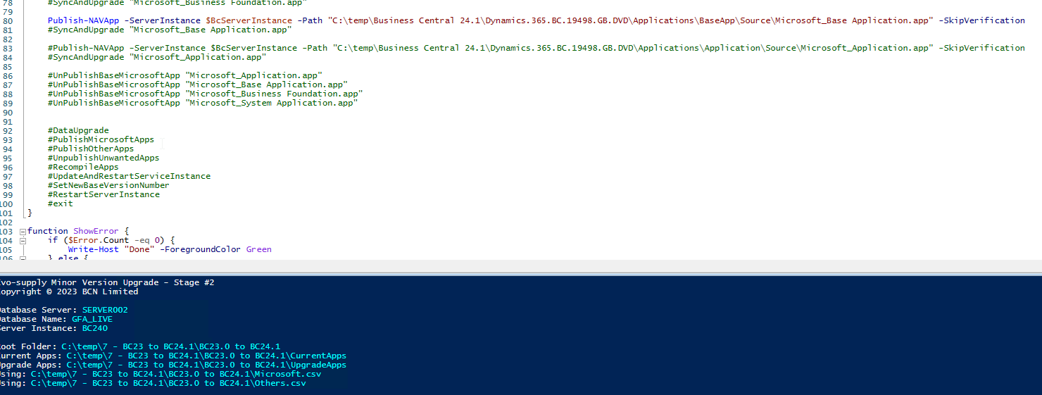

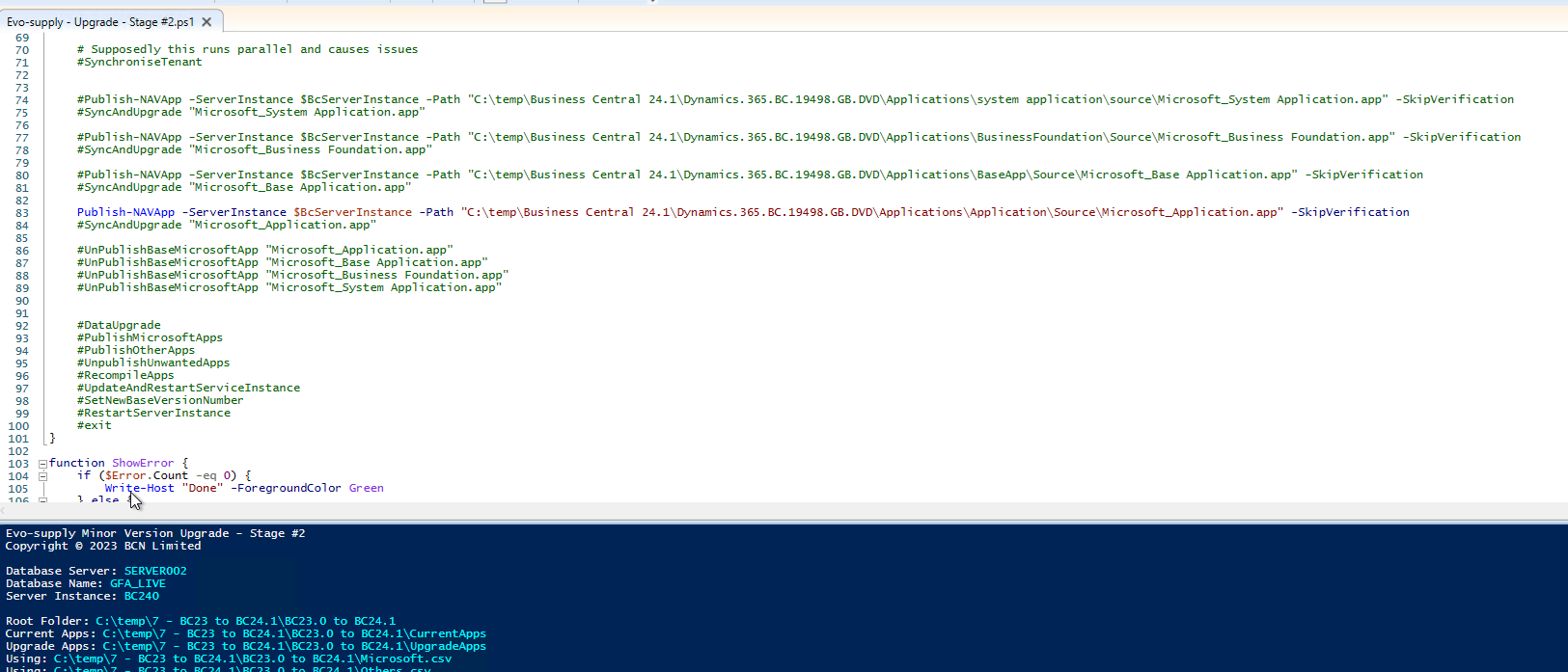

There is no need to upgrade Business Foundation since it’s the first time that is installed on the database.

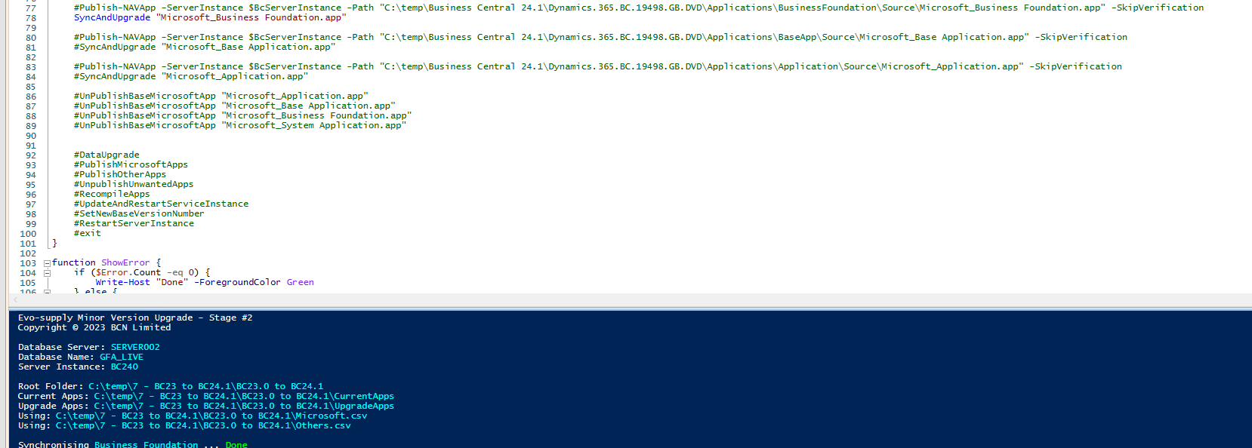

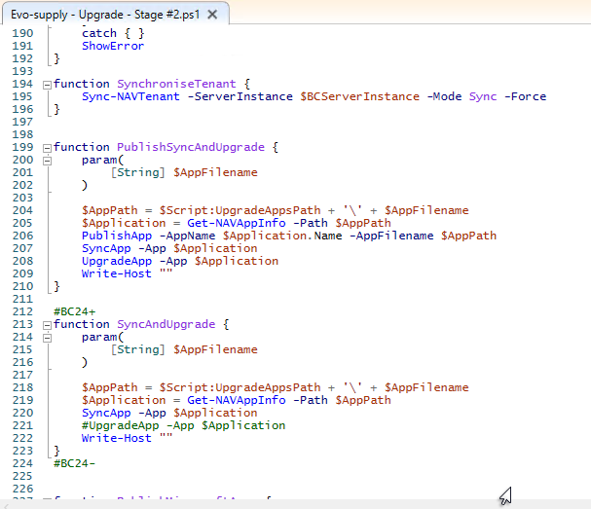

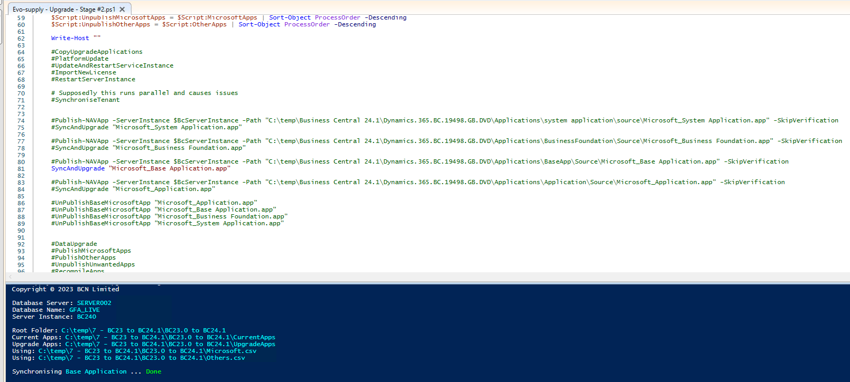

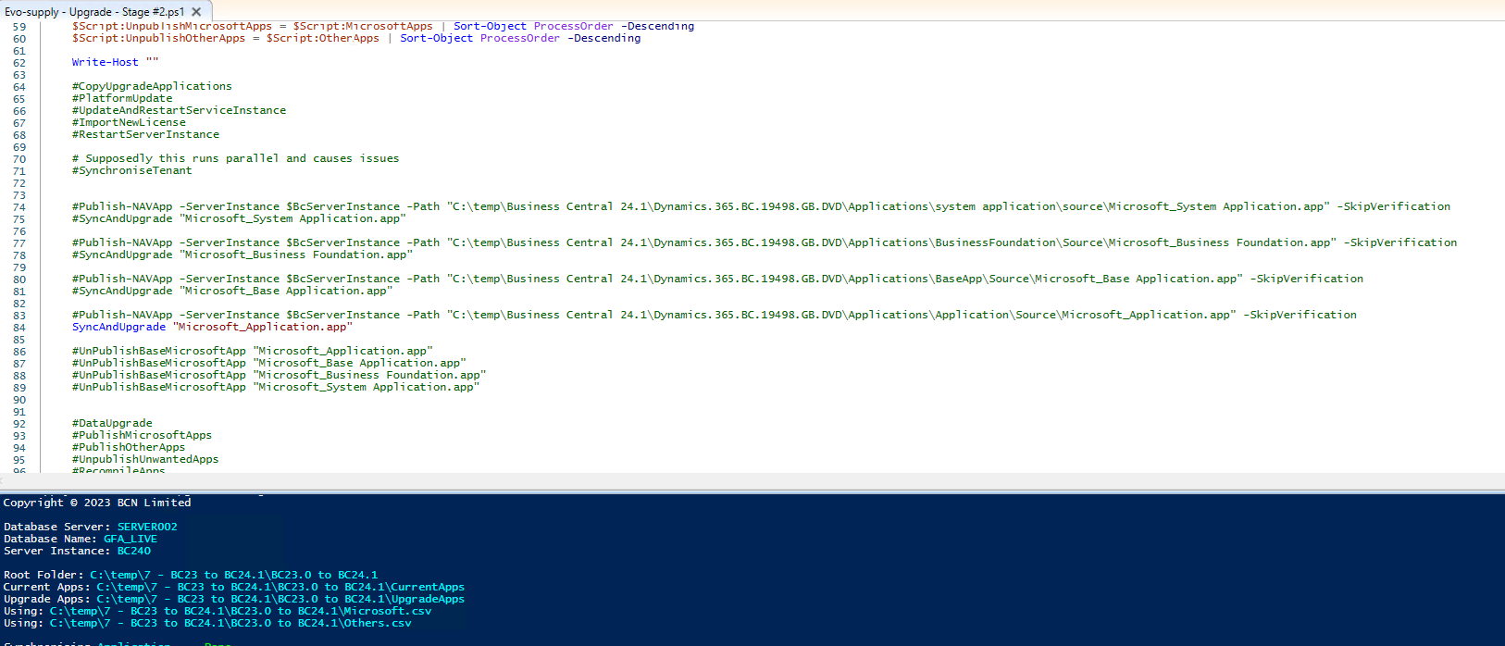

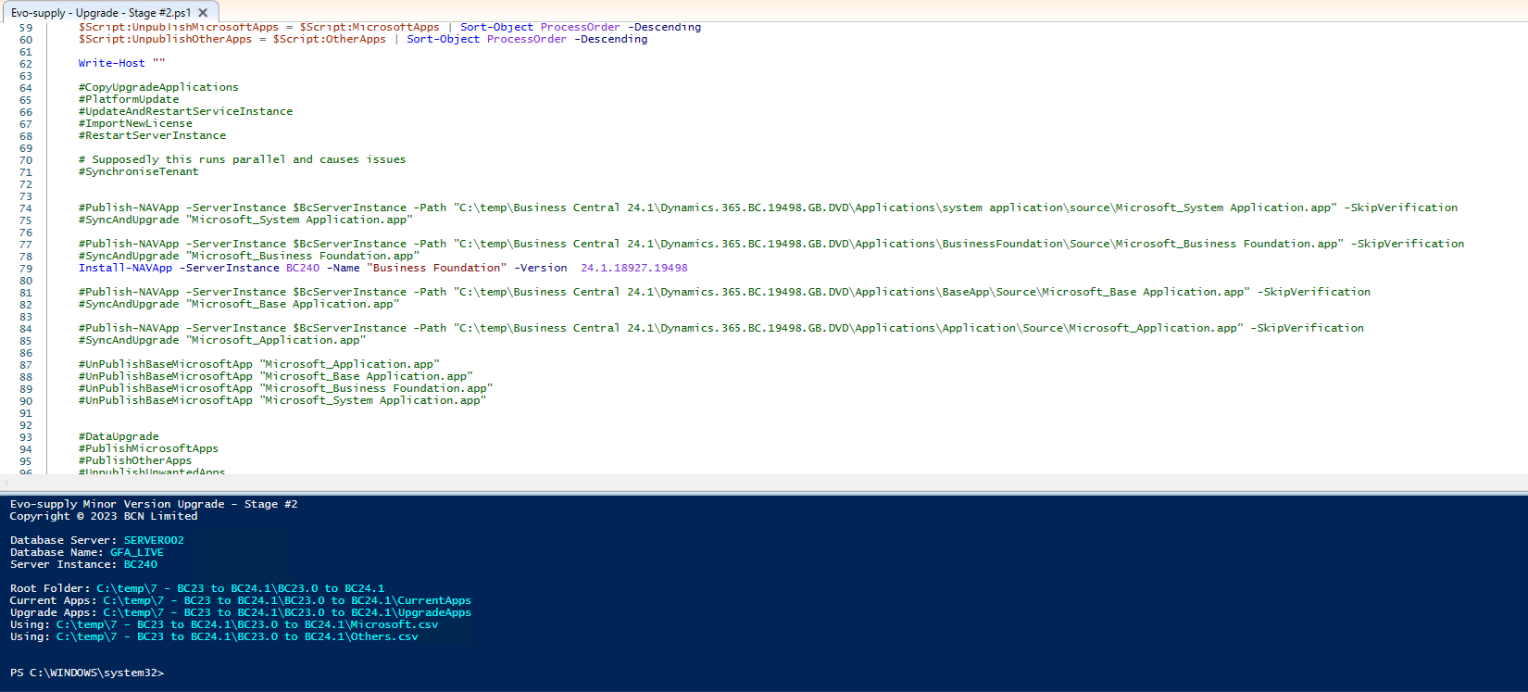

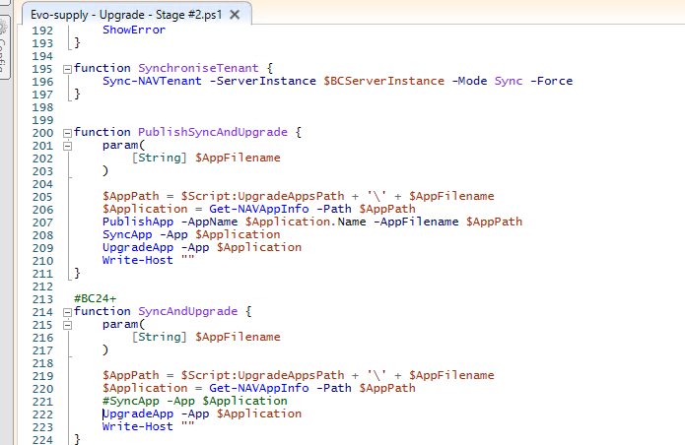

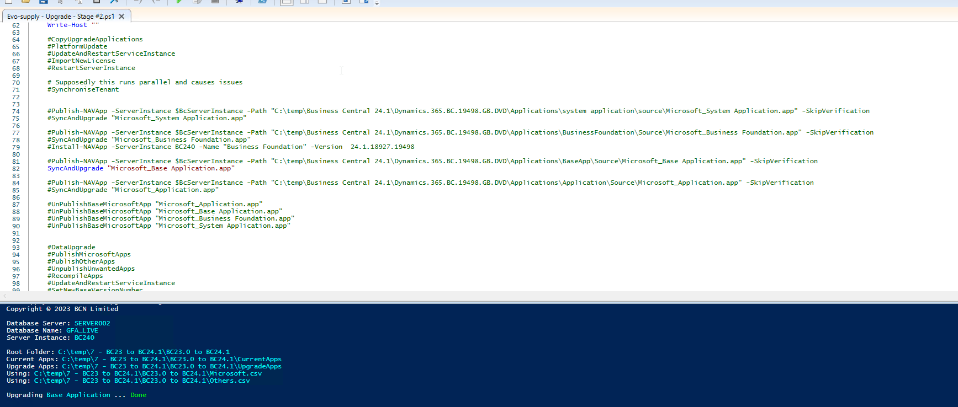

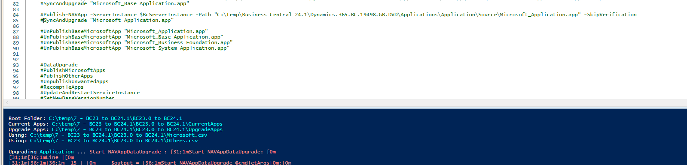

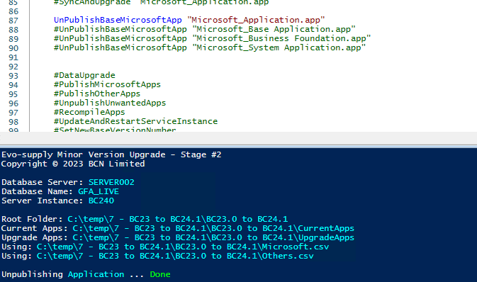

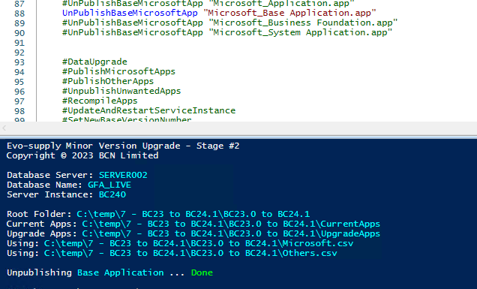

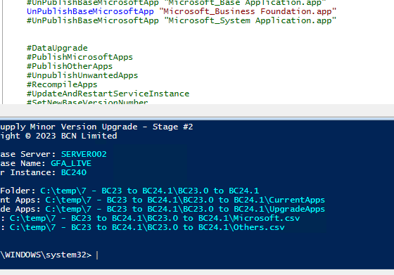

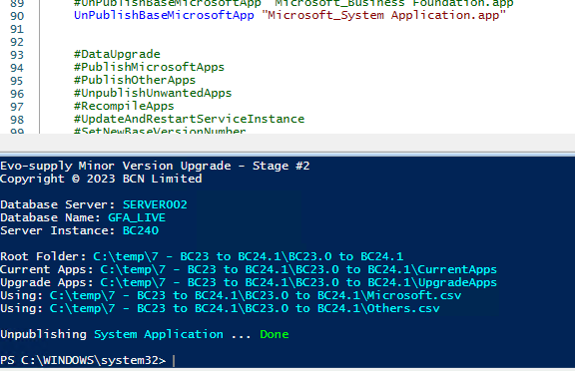

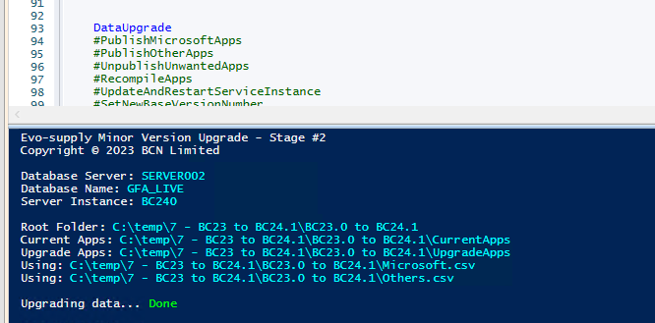

Like the previous exercise Publish MicrosoftApps will fail. We need to publish/install/sync the extensions manually.

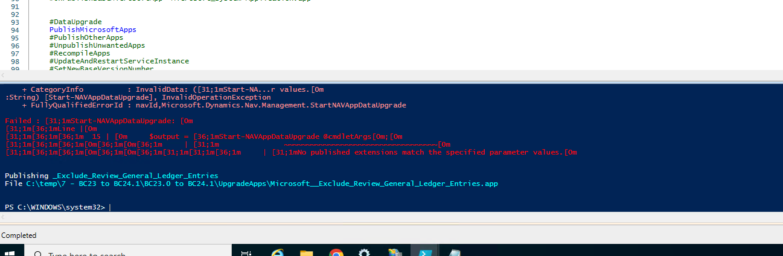

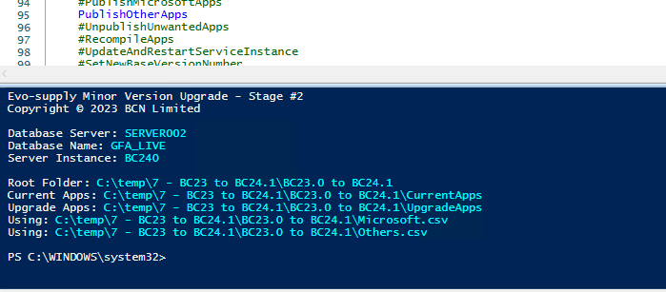

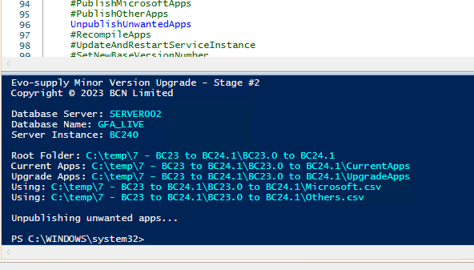

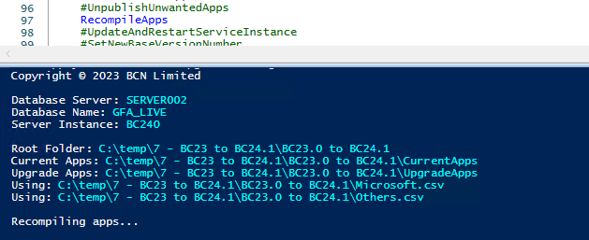

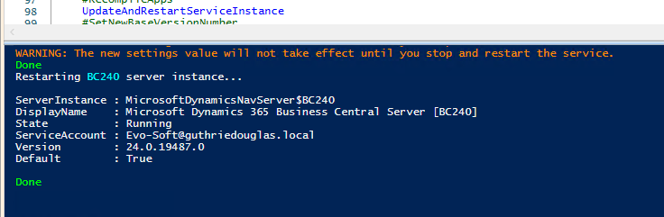

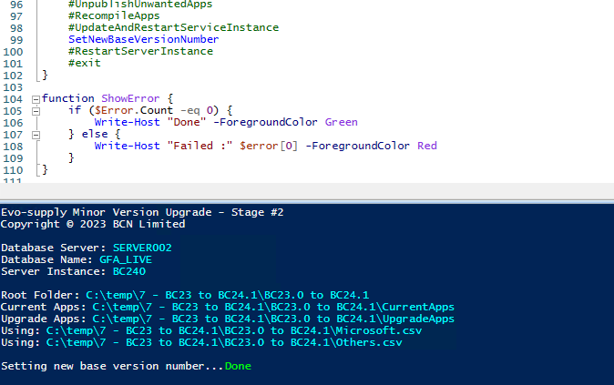

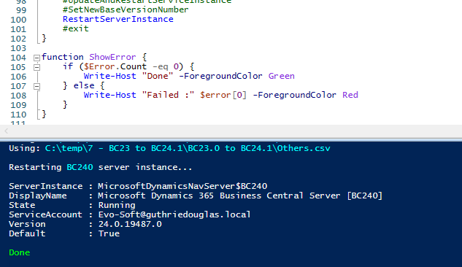

There is no need to upgrade Business Foundation.

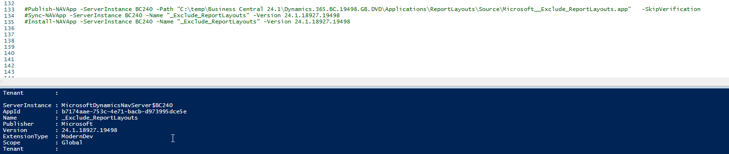

When following the BC23 upgrade script from (BC14) several Microsoft apps were installed so they appeared on the final version BC24CU1 so the following script was used to clean the old ones and Publish the new ones, then manually just to control which one (comparing a CRONUS) the Install/Sync was actioned from the Web Client (Extension Management page).

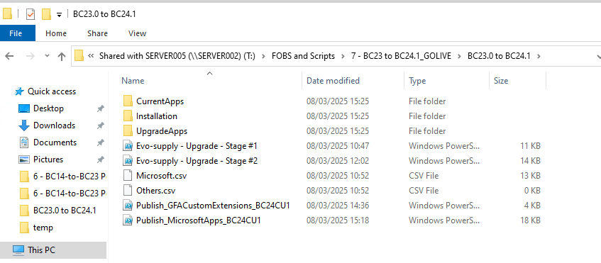

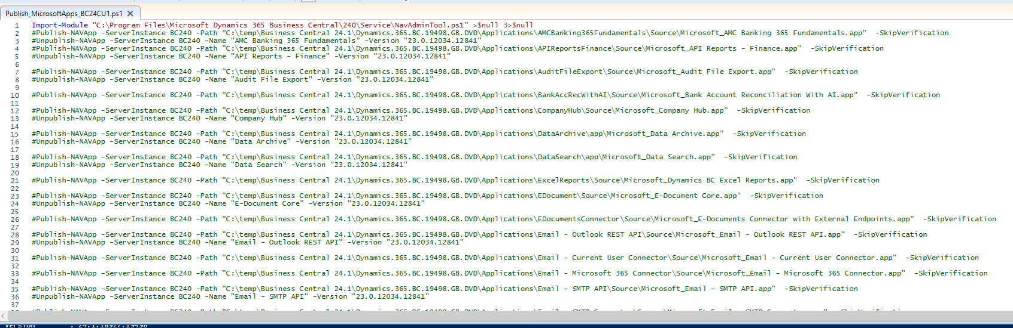

Note: on this script was added the _Exclude_Report_Layouts extension.

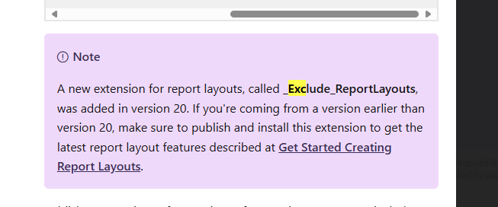

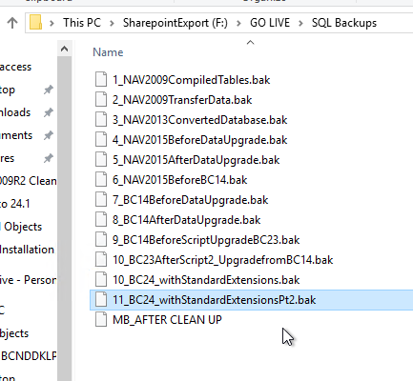



GFA Custom Extensions were also installed:

